

**National Alliance for Public Safety GIS Foundation**

**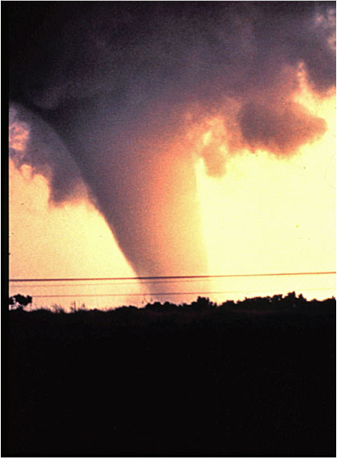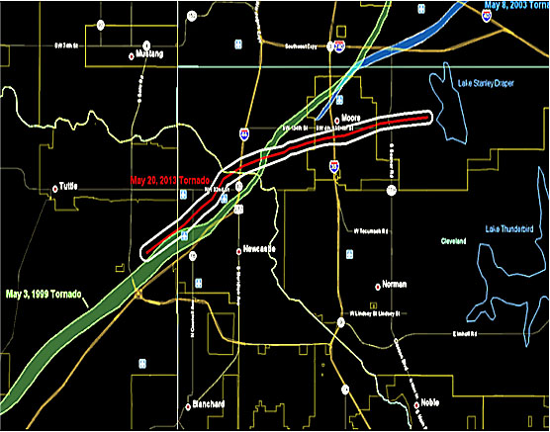**

**Geospatial Standard Operating Guidance for Multi-Agency Coordination Centers**

***SUPPLEMENT FOR TORNADOES***

**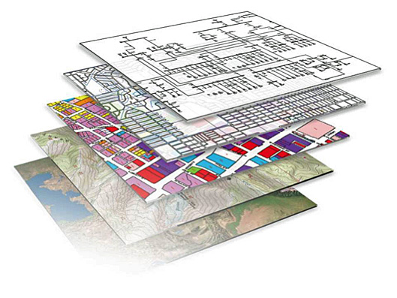**

# TABLE OF CONTENTS

TABLE OF CONTENTS 2

List of Figures 5

CREDITS 6

DOCUMENT BACKGROUND 8

Tips on How to Use this Guidance Document 9

INTRODUCTION 10

How GIS Can Assist Emergency Managers and First Responders? 15

What Types of Questions Can GIS Answer? 15

What is GIS? 16

What Resources Are Needed/Where Can I Get Them? 17

FEMA Emergency Management Institute 21

NAPSG Quick Guide 21

keys to the successful use of gis that emergency managers & first responders should know 22

What GIS Professionals Need to Know About Emergency Management 23

Homeland Security GeoCONOPS 23

Emergency Management Systems 24

Emergency Operations Center 26

Emergency Management Assistance Compact 27

International Charter 27

Crisis Information Management Systems 27

Glossary of Emergency Management Terms and Definitions 28

keys to the successful use of gis FOR A TORNADO EVENT that gis professionals should know 30

Critical Actions and Activities 30

Standard Operating Procedures for Tornadoes 37

GIS Team Preparation Checklist 37

GIS Team Standing Orders for a Tornado 37

Example - GIS Team Standing Orders Tornado – Pre-Impact 38

Example - GIS Team Standing Orders Tornado – Post-Impact 41

GIS Resource & Staffing Requirements 43

Resource Requirements 44

Staffing Requirements 46

GIS Roles and Responsibilities 47

GIS Responder Expectations 47

Shifts and Team Transition 48

ICP/DOC/MOC GIS Staffing 48

Team Transition 48

File Naming and Directory Structure 50

GIS File Directory Structure 50

GIS File Naming Convention 52

Communication 53

Mapping Protocols 55

User Defined Operating Picture 55

Consumable Services 56

Map Templates 56

Map Elements 57

Product Format Conventions 57

Map Symbology Guidelines 57

Map Distribution Regulations 58

QA/QC 58

Archiving 59

Standard Map Product Definitions 59

Optional Map Product Definitions 59

Data Protocols 60

Data Format Conventions 61

Briefing Cycles 61

Data Backup Policy 62

Information Availability 62

Data Acquisition and Dissemination 63

Data Management Plan 63

Obtaining Event Data 64

Essential Elements of Information 64

Determining the Tornado’s Path 70

Compiled Imagery 74

Crowd Sourced Data 74

Damage Assessment 75

Calculating the Cost of the Storm Damage 76

Calculating Debris Removal Quantities and Costs 76

US National Grid 77

International, National & Federal GIS Products and Programs 77

State/Local GIS Products and Programs 79

Data Dissemination 79

Data Dissemination Protocols 80

Information Dissemination Protocols 80

Data Connections 81

Enterprise Geodatabase 81

GIS Emergency DVD or Hard Drive 81

Public Data Sharing/Exchange Policy 82

Documentation and Metadata 84

Dissemination of Metadata 84

Indexing Metadata to Facilitate Discoverability 84

Training/Exercises 86

Training 86

Exercises 87

Appendix 1: GIS Preparation Checklist 88

Appendix 2: List of Acronyms 92

Appendix 3: Glossary of Emergency Management Terms and Definitions 95

Appendix 4: GIS Products and Programs 97

Appendix 5: NOAA WEATHER DEFINITIONS 98

Appendix 6: EXAMPLE OF GIS ROLES AND RESPONSIBILITIES 99

Appendix 7: GIS Data Needs for a Tornado (For State EOC Support) 101

Appendix 8: Tornado Scenario Training Exercise FOR LOCAL GOVERNMENT 105

Appendix 9: FEMA’s Suggested Training REsources for GIS Users 108

# List of Figures

Figure 1-All Tornadoes in the US, 1950-2013, Highest EF-Scale on Top (Alaska and Hawaii negligible) 10

Figure 2-Examples of GIS Displayed in an EOC 16

Figure 3-Damage Assessment Data Following the Joplin Tornado 17

Figure 4-Field Staff Use GPS Devices to Perform Damage Assessments after an EF3 Tornado Hit 18

Figure 5- Example of GIS Displaying Imagery Before and After a Tornado 19

Figure 6- Preliminary Business Impact of Joplin Tornado 20

Figure 7-Example of an ICS Organizational Structure 24

Figure 8-FEMA Multi-Agency Coordination System Diagram 25

Figure 9-Example of the Physical Layout of an Emergency Operations Center 26

Figure 10- Missouri U.D.O.P. Displays N.W.S. Storm Reports of a Deadly Storm 28

Figure 11- Nursing Homes in the Damaged Area of the Joplin Tornado 31

Figure 12-Radar Images of the Moore Tornado with a Debris Ball and Signature Hook Echo 35

Figure 13- GIS Team Standing Orders for a Tornado - Pre-Event 40

Figure 14-GIS Team Standing Orders for a Tornado – Post-Event 42

Figure 15-Example of a GIS Supply List 46

Figure 16-Example of a Directory Structure 51

Figure 17-Example of a GIS File Naming Convention 52

Figure 18-Example of Data Format Conventions 61

Figure 19-Example of a Data Backup Policy 62

Figure 20-Example of Datasets Recommended Prior to a Tornado 68

Figure 21-Example of Datasets to be Acquired After a Tornadic Event 70

Figure 22-Social Media Feeds Displayed in an Interactive Map 72

Figure 23-Model for Quickly Determining the General Location of a Tornado 74

Figure 24-Example of a FEMA Wind Damage Classification 76

Figure 25-Example of a GIS Press Package Policy 83

Figure 26-Tornado Damage Description 98

Figure 27-Tornado Damage Description 100

Figure 28-GIS Data Needs Identified by Missouri 104

# CREDITS

Many dedicated leaders in the public safety and GIS communities supported the development of this Geospatial Standard Operating Guidance (SOG) for tornado response. In smaller events, this may just involve local and State governments, and, of course, the National Weather Service. On larger events, this may involve the Federal Emergency Management Agency and other Federal agencies that participate in response coordination with the state and local emergency responders following the National Response System protocols.

Foremost, the National Alliance for Public Safety GIS Foundation and its partners in the project are grateful for the time and expertise that so many practitioners contributed in developing this:

David Alexander, Director, DHS Geospatial Management Office (GMO)

David Allen, GIS Manager, City of Euless, TX

Charles Brady III, GISP, GIS Coordinator, City of Ardmore, OK

Debbie Briedwell, GIS Manager, Missouri State Emergency Management Agency

Bill Burgess, Washington Liaison, National States Geographic Information Council

Brian Crumpler, ISP Coordinator for Northern Virginia, Virginia Information Technologies Agency

Tony Foisy, Project Manager, GISP, CSX

Heather Gilbert, Project Manager, National Oceanic Atmospheric Administration (NOAA)

Devon Humphrey, Founder and CEO, Flightline Geographics, Inc.

Shelby Johnson, Geographic Information Officer, Arkansas

Rezwan Karim, Flood Map Specialist, FEMA

John Luther, Director of Emergency Management/911 Operations, Washington Co, AR

Jason Lyon, GIS Coordinator, City of Conway, AR

Jim McConnell, Assistant Commissioner for Strategic Data, Director, Geographic Information Systems, New York City Office of Emergency Management

James E. Mitchell, PhD, IT GIS Manager, Louisiana Dept. of Transportation & Development

Robert Moore, GISP, Catastrophe Risk Analyst II, American Modern Insurance

Bruce Oswald, Project Manager/Principal Author, National Alliance for Public Safety GIS Foundation (NAPSG)

Mike Ouimet, Manager for Critical Information Systems (HQ), Texas Department of Public Safety Texas, Division of Emergency Management,

Jon Paoli, GIS Coordinator, Iowa Homeland Security & Emergency Management

Daryl Pemberton, Deputy Director 911 Operations, Washington Co, AR

Tony Spicci, Planning Team Manager/Technical Information Officer, Missouri Task Force 1, Urban Search and Rescue

Shellie Willoughby, GISP, Assistant State Geographic Information Coordinator, Oklahoma Office of Geographic Information

*Note – Cover Images were taken from Wikipedia and NOAA*

# DOCUMENT BACKGROUND

This Standard Operating Guidance document was developed by a team of Geographic Information Systems (GIS) specialists and professionals, leaders in public safety operations & management and incident support subject matter experts. It strives to serve as a template to support national GIS standards for tornadoes using GIS and technical professionals, embedded within an Incident Command System (ICS) structure.

This document proposes a set of guidelines for coordinating geospatial emergency response efforts. These guidelines are intended to serve as a shared foundation, encouraging improved communication and collaboration amongst GIS and other emergency management staff preparing for and responding to tornadoes. How these guidelines are implemented will depend on the organization and the level of government responding to the incident. This living document provides a starting point to produce guidelines for the collection, organization, and management of geospatial data; map creation; and output within Multiagency Coordination Centers (MACC’s) for tornadoes. It is anticipated that this document will be updated as more local agencies adopt GIS operating procedures for emergency management and provide best practices back to the NAPSG Foundation via [admin@publicsafetygis.org](mailto:admin@publicsafetygis.org" \t "_blank).

Intended as a template, agencies are encouraged to modify document content to accommodate local and regional specific details. Modifications may range from referencing local datasets and file locations to adjusting standard map products to better account for local hazards or values at risk. It is recommended that the GIS Team Leader and the emergency management staff work closely together to create a Standard Operating Procedure (SOP) or Standard Operating Guidance (SOG) that integrates GIS with their emergency management workflow and meets the unique needs of their local or State agency (and/or jurisdiction) for tornadic events.

The Department of Homeland Security’s (DHS) Homeland Security Geospatial Concept of Operations (GeoCONOPS) provides additional information on federal geospatial activities undertaken in support of emergency management. The Homeland Security GeoCONOPS is a strategic roadmap to understand, and improve, the coordination of geospatial activities across the entire spectrum of the Nation: from federal, to state, and local governments, to private sector and community organizations, academia, the research and development industry and citizens in support of Homeland Security and Homeland Defense (HD). The Homeland Security GeoCONOPS is structured to address key mission areas of prevention, protection, mitigation, recovery and response. To obtain a copy of the Homeland Security GeoCONOPS, visit: <http://www.geoplatform.gov/sites/default/files/geoconops/DHS_Geospatial_CONOPS_v6_SCREEN_140529.pdf>. In addition, the DHS GMO has developed several self-paced, on-line training courses that are valuable to both emergency management personnel and GIS professionals. These courses are available on the FEMA Emergency Management Institute (<http://www.fema.gov/contact-us/fema-training-emergency-management-institute>).

## Tips on How to Use this Guidance Document

Within this document, *background information* on each section is offered in blue text boxes at the beginning of each chapter*.* The background information is intended to guide the user on how to utilize the associated guidance. Text which is bold, italicized, and in carrots delineates where **<<*local jurisdictional input is needed>>***. Examples are given in motion quotes and are intended to provide the reader with tips on how to use and interpret the examples provided. Diagrams are also marked as examples to indicate where local inputs are required. Please note that all examples and diagrams are offered up only for reference purposes and are not intended to set a standard. Not all MACC’s are alike. Be sure to modify the examples given to fit the needs of your facility. While there has been a significant effort to identify the acronyms used in the text, a comprehensive list has been compiled in Appendix 2.

It is recommended that, once your agency has created a GIS operations document for tornadoes, it be exercised when emergency management agencies or first responders conduct scenario-based exercises. During these exercises, GIS products should be developed and delivered by the GIS Team and used by the emergency management staff to specifically test different elements within the document. Subsequent to the exercises, an After Action Report (AAR) should identify areas of the document and GIS response that worked, and those that need improvement. The SOG should be updated after each exercise to improve its effectiveness.

For more information on how to integrate geospatial technologies within your public safety organization, please visit <http://carat.napsgfoundation.org/> for best practices and a prototype version of the interactive Capability and Readiness Assessment Tool (CARAT). The CARAT is intended for public safety practitioners interested in learning about and/or building a GIS to support their agency's work. It is designed to serve as an assessment tool to develop a roadmap for anyone interested in learning about, doing, or directing a GIS in support of public safety.

# INTRODUCTION

***Purpose*:** This Standard Operating Guidance document (SOG) was prepared to provide guidance and key components of a template to help facilitate local and State agencies with the creation, preparation, coordination, and dissemination of GIS services and products for a tornado event. While this document is aimed at serving both local and State government needs, it recognizes that most tornado responses occur at the local level with State government providing support as needed (i.e. imagery contracts, staff, map products, data backup, etc.). It also understands that the role of the GIS manager at the local and State levels may differ from “hands on” GIS output to an almost exclusive coordination role. Accordingly, each organization using GIS to assist in their operations must determine how to best allocate staff resources to serve their unique mission.

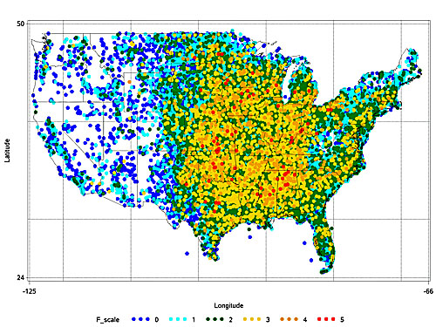

Figure 1-All Tornadoes in the US, 1950-2013, Highest EF-Scale on Top (Alaska and Hawaii negligible)

(Source [NOAA](http://en.wikipedia.org/wiki/NOAA) [Storm Prediction Center](http://en.wikipedia.org/wiki/Storm_Prediction_Center))

Unlike other natural occurring events like hurricanes (which may be tracked for several days prior to reaching landfall and impact larger geographical areas over multiple days), tornadoes can deliver a devastating impact to a community in a relatively narrow path with little or no advanced warning. In addition, they can be extremely deadly. Over the past 30 years (1985-2014), an average of 1,141 tornadoes occurred in the contiguous U.S. each year.[[1]](#footnote-2) These events resulted in a yearly average of 73 fatalities.1 In 2014 alone, $17 billion[[2]](#footnote-3) in economic losses were reported.

Tornadoes can happen at any time of year, and any time of day or night, but most tornadoes typically occur between 4-9pm. Nocturnal tornadoes, while compromising only about a quarter of verified tornadoes, produce about 42.5 percent of tornado fatalities.3 Nocturnal tornadoes pose a significant challenge as they limit the ability to immediately ascertain situational awareness of their impact to a community. The current average lead-time for tornado warnings is about 13 minutes. Most tornadoes last less than 10 minutes, but a few have been known to last for several hours. Their paths can be as narrow as a couple of hundred yards to more than 2.5 miles wide.[[3]](#footnote-4) An EF5 tornado (refer to Figures 29 and 30) can deliver winds of over 200 mph, leveling almost all structures in its path. These factors create unique parameters in which GIS professionals serving the emergency management community must operate to meet their community’s needs.

Can GIS technology provide significant assistance to emergency managers and first responders facing the need to plan for, respond to, and recover from the devastating impacts of a tornado? The answer is a resounding yes! However, to obtain the best results, preparations must be made far in advance. These preparations, which are detailed in the SOG, include: establishing a GIS Team within the EOC (whether it be one person or a team of staff); obtaining relevant data; establishing relationships with the National Weather Service (NWS) local Weather Service Office or Regional Operations Center; learning how to use appropriate weather and other data services; working with emergency managers in the Emergency Operations Center (EOC) to establish a schedule for the delivery of GIS products to maximize their benefits; and the incorporation of GIS products into the emergency response workflow.

Initially, the biggest problem for GIS professionals is determining the tornado damage path. Currently, there is no common established methodology for determining the damage path immediately following a tornadic event, however, the NWS is working to establish these protocols. Ideally, an immediate ortho-rectified (geographically correct) image of the impacted area would provide the GIS professional in the EOC with the ability to visually identify the impact of the tornado to the community as a whole, including but not limited to the population and critical infrastructure. Usually, the most immediate imagery available to local government is a video clip or photo from a helicopter taken by a local TV station. Other possibilities range from the use of trained observers on the ground and/or first responders, social media, or geo-referenced pictures from residents in the community. Several states have successfully utilized a method developed by the Commonwealth of Virginia that incorporates weather radar data to provide an approximate tornado path. This has proven to deliver some of the most immediate results. NWS continues to develop and expand its preliminary tornado track assessment capabilities immediately following high-impact events.

The key to using GIS during rapidly unfolding and high-impact tornado events is to be organized. Have a schedule of standard GIS products that will be produced. Have a method to deliver those products rapidly (and a backup) that will be used after the tornado hits. Have emergency managers and first responders trained in how to best use the GIS products to assist them in their roles. Work with them to ensure the use of these products is integrated into their workflows.

Keep it as simple as possible. Test your procedures with the staff and modify the methodology as required when technology advances.

Have forms for data collection created (i.e. damage assessment, search and rescue, hazardous materials, etc.). Ideally, the forms would be digital, and data would be transmitted automatically back from the field. However, in the event of a service or equipment disruption, or the trained staff isn’t available, have a simple, paper backup approach available as well.

Remember, even the most dedicated staff will likely respond to family needs in the impacted area before they return to first responder duties. Establish relationships with trusted GIS professionals in the surrounding communities, regions, and at the state level that can assist, share the workload and/or provide backup staffing quickly when an event strikes. If possible, hold scenario-based exercises for the GIS staff that incorporate the use of field equipment, data, templates, etc. prior to the typical tornado season. Finally, meet regularly with the GIS Team, emergency managers and first responders to discuss strategies, methodologies, data needs, templates, etc. to coordinate and/or standardize your approaches.

This SOG is a living document that provides a starting point to produce guidelines for the organization, management of GIS data, map creation, and outputs within Multi-Agency Coordination Centers (MACC’s). Additionally, proper internal and external communication channels for sharing these products are addressed.

It is essential that the major planning, organizational needs, data gathering, template development and training be completed long before the traditional tornado season approaches. This document attempts to apply many of the lessons learned during previous storms to better prepare for future events. It is intended to provide emergency managers, first responders and GIS professionals another tool that can be used following a tornado event to improve their ability to respond to and recover from future tornadoes.

***Audience:*** The intended audience for this document includes all local and state staff assigned to GIS support roles for tornadoes. This document is meant for use within Operations Centers and the Multi-Agency Coordination System, and follows the National Incident Management Structure (NIMS). NIMS states that EOC’s do not have to be organized around the Incident Command System (ICS). This document is not intended for use by the Incident Command, and does not follow direct guidance procedures mandated in ICS. For more information about GIS use within ICS, please see the National Wildfire Coordinating Group GIS Standard Operating Procedures (GSTOP, June 2006) (<http://www.nwcg.gov/pms/pubs/GSTOP7.pdf>). Components of this guidance document can be adopted and applied to the development of SOP’s or SOG’s for ICS specifically.

For additional information on federal geospatial activities in support of emergency management, please see the Homeland Security Geospatial Concept of Operations (GeoCONOPS) coordinated by

the Department of Homeland Security Geospatial Management Office (GMO). To obtain a copy of the Homeland Security GeoCONOPS visit the Homeland Security GeoCONOPS Website at: <http://www.geoplatform.gov/sites/default/files/geoconops/DHS_Geospatial_CONOPS_v6_SCREEN_140529.pdf>.

***Objectives:***

Seven objectives were set to adequately address GIS needs and practices in an emergency event:

1. Develop standard operating guideline templates for tornadoes with a focus on State and local government needs.
2. Ensure the document and standards are consistent with the Homeland Security GeoCONOPS and the current NAPSG SOG.
3. Provide guidance for State and local GIS professionals without a meteorological background to be able to quickly understand what is required and how to be more effective.
4. Determine key GIS resources and tools for MACC’s such as Incident Command Post (ICP), Department Operations Center (DOC) or Medical Operations Center (MOC).
5. Determine data and mapping protocols.
6. Determine and document protocols for data/map dissemination/sharing via web applications.
7. Determine data and map sharing practices with external partners.

In order to meet these seven objectives, this document is broken down into the following chapters:

* How GIS Can Assist Emergency Managers and First Responders – This section aids emergency responders who may be unfamiliar with the usefulness of GIS by providing an overview of the capabilities that GIS can offer for tornado events.
* Keys to the Successful Use of GIS that Emergency Managers and First Responders Should Know – Provides general information about the use of GIS to emergency managers and first responders to help them optimize the utilization of GIS technology and data to its full potential.
* What GIS Professionals Need to Know About Emergency Management – Outlines the various emergency management organizational structures and physical layout of the MACC to aid GIS staff when providing support within an Emergency Operations Center (EOC).
* Keys to the Successful Use of GIS that GIS Professionals Should Know – Provides general information to GIS professionals to help them understand the best ways in which GIS and available technology, procedures and data can be used during an event.
* Standard Operating Procedure for Tornado Response – Discusses the main components involved in a tornado response, including:
* GIS preparation checklist
* GIS Team’s standing orders
* GIS staffing and resource requirements
* Mapping and data protocols
* Damage assessment
* Product tracking, documentation and metadata guidelines
* Communication
* Training and exercises

While it is suggested that this document be read in its entirety, the authors also realize that individuals may choose to read only certain chapters directly related to their emergency management role(s). For that reason, each chapter is written to work as “stand alone” guidance, and some material may be repeated. It is hoped that this will be understood by the reader and serve to reinforce that information. However, it is important for every member of the response team to develop a familiarity with the roles of their colleagues and how they interact.

# How GIS Can Assist Emergency Managers and First Responders?

Tornadoes can strike with little or no warning and can be deadly. They affect a community and its surrounding jurisdictions whether big or small. All phases of emergency management involve the collection, analysis, and dissemination of GIS data/information in an organized and logical manner. Geographic Information Systems (GIS) can provide a mechanism to rapidly organize, analyze and visually display information relevant to a tornado and its impacts to the community. Once the path of the tornado has been determined, GIS professionals can assist emergency managers and first responders in meeting the majority of their planning, operational response and recovery needs.

GIS can allow emergency managers and first responders to better visualize the storm’s path and the number of people, schools, businesses and infrastructure impacted, so that emergency managers can quickly formulate an appropriate response and forecast recovery needs. This information can be displayed in maps, charts, graphs, reports or web sites to effectively disseminate the appropriate information to government officials, responders and the general public.

Because little or no time transpires between when tornado hits a community and leaves it in its deadly wake, there is no time to lose for emergency managers, first responders and GIS professionals after an event occurs. If GIS is to be fully effective, planning, training, and integration of the use of GIS in the emergency management workflow must be completed prior to tornado season. Decisions need to be made on what issues are key for the emergency managers and first responders during a tornadic event. Relevant GIS products must be provided in a timely manner to assist them.

## What Types of Questions Can GIS Answer?

With accurate geospatial information, GIS analysts can answer many questions. Of particular interest when responding in an EOC to a tornado event, one may be interested in the following:

* + What were the path of the tornado and the extent of the damage?
* What critical infrastructure was impacted?
* Are there hazmat/gas/chemical threats?
* Where is the power out?
* Where are electrical lines that are down and potentially active?
* What roads and bridges are open/closed?
* Where is the security perimeter?
* What are the vehicle access routes?
* How much debris must be removed from those access routes to aid responders?
  + How do I find things?
* Where are the maps for the first responders?
* Where is search and rescue being conducted?
* Who is covering what sectors?
* Where are our vulnerable citizens?
* Where are the staging areas, command posts, medical triage facilities and shelters?
* Where are the debris dumping sites?
  + What were the population and businesses impacted?
* What are the value of the property damage and the cost of debris removal?
* What is the financial impact of damaged businesses? Where are alternative resources located?

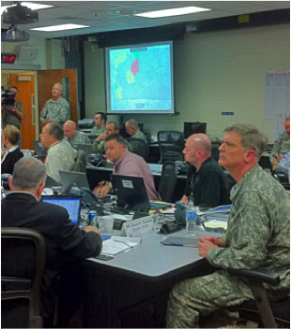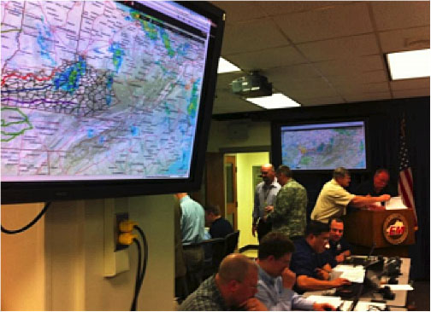

Figure 2-Examples of GIS Displayed in an EOC

(Source – NAPSG)

## What is GIS?

A GIS (often called “mapping”) is an information system that understands location. While it requires hardware and software, up-to-date and relevant geospatial data is the key for it to provide accurate solutions. Much more than a map, a true GIS adds analytical capability that informs decision making while providing the ability to model and assess a storm’s impact on a community and its critical infrastructure.

GIS products are built with layers of data. Each of these layers can be displayed together to depict a relational location perspective. For example data can include static or real-time information, such as:

* Weather information
* Tornado path
* Search zones
* Daytime and nighttime population data
* Businesses, schools and other critical infrastructure within the tornado path/area of damage
* Businesses, schools, and other critical infrastructure and resources outside the tornado path/area of damage that can be used during response/recovery
* Roads/bridges
* Land use/land cover
* First responder vehicle locations and movement
* Place names and boundaries

During operations, GIS can provide situational awareness on search and rescue, damage assessment, evacuation efforts and perimeter security needs. For recovery, GIS can be used to quickly estimate the cost of the damage and the amount of debris to be removed. The figure below effectively depicts the areas of greatest damage caused by the tornado.

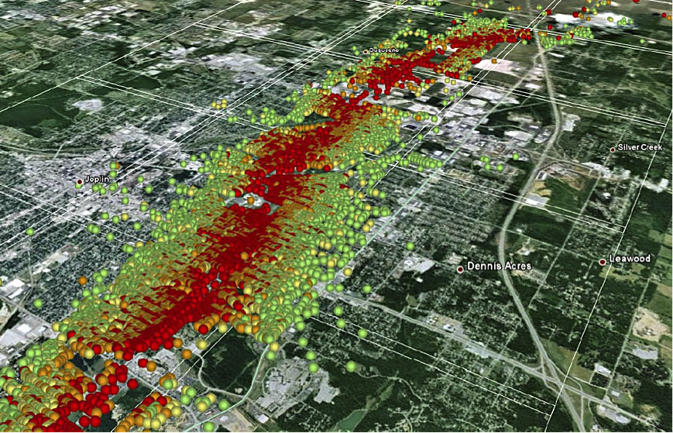

Figure 3-Damage Assessment Data Following the Joplin Tornado

(Source –FEMA)

GIS has a distinctive analytic ability that brings together otherwise diverse datasets. **Because information can be organized by its location on the earth, a user can see relationships that are not evident in text reports. GIS provides the type of situational awareness that enhances incident-level decision-making to save lives and protect property as well as critical facilities.**

## What Resources Are Needed/Where Can I Get Them?

In order to operate a successful GIS-based response, two areas must be addressed. The first of these areas is technical and includes obtaining hardware (computer equipment), GIS software, data (reflecting pre-event and post-event conditions) and trained staff. The second is “social” and requires integrating the GIS products into the emergency management decision-making process by emergency managers and first responders through analysis and scenario based training. Without the latter, the EOC risks developing an expensive system for making cartographically derived wallpaper!

NAPSG provides a tool that allows you to assess both your current GIS capabilities and to understand where GIS can be used to further improve your current decision making capabilities. This tool, called a Capability and Readiness Assessment Tool (CARAT) is available at: <http://www.napsgfoundation.org/carat/>. Additional information on items suggested to develop a robust GIS is available later in this document under the section entitled, “GIS Resource & Staffing Requirements” and in Appendix 1.

If you don’t already have GIS in your EOC, it is suggested that you consult with a GIS professional in a neighboring jurisdiction or your State GIS Coordinator: <http://www.nsgic.org/state-representatives> on your hardware and software needs. While hardware may be viewed as fairly “generic”, software generally falls into two basic categories. These are more mature proprietary software systems (Esri being the largest commercial company in this arena) and open software systems (these software products are free to use, but may require some additional programming costs to accommodate your specific needs). Once again, it is suggested that you work with a GIS professional to assist you in making a decision on what is most appropriate to meet your needs.

Having the latest data on “existing conditions” in your community, county or state is essential to providing an accurate picture of the impacts of an event. While there are a number of sources for this data, local communities and State GIS clearinghouses provide the most accurate and up-to-date versions. Other sources include the National States Geographic Information Council’s “GIS Inventory” (<http://gisinventory.net>) and the Federal Government’s Data.Gov site (<http://www.data.gov/open-gov/>).

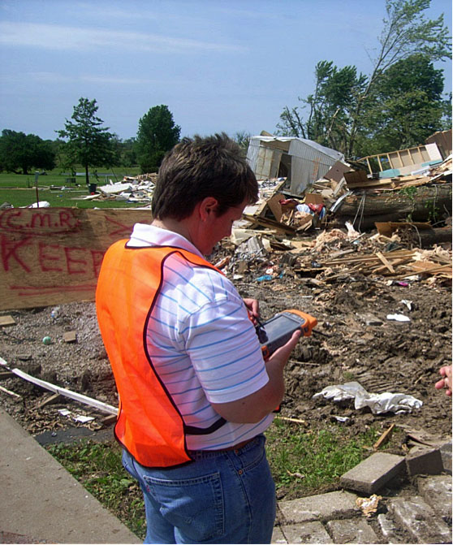

Figure 4-Field Staff Use GPS Devices to Perform Damage Assessments after an EF3 Tornado Hit

(Source – Missouri Emergency Management Agency)

The other, equally important type of data is “post event” data. One of the most immediate data needs once a tornado strikes is to locate the path that the tornado took. Ideally, this would be done immediately in the aftermath by an overhead picture. Often, that is not practical and putting “feet on the ground” to gather this data is the only realistic manner available to gather information rapidly. In order to do that effectively, a methodology should be developed and tested. Next, standard operational procedures and an appropriate training program should be put in place for data collection by “designated” staff prior to tornado season to insure that the individuals on the ground are trained, and that the data is provided to the GIS Team in the EOC in a rapid and seamless manner. Once that is done, a number of GIS products can be provided. The National Weather Service is in the process developing a number of new products to improve reporting on pre- and post-tornado situations. At present, tornado watches and warnings are provided. In addition, their local offices make data on the tornado path available. However, the timing of this product is often too late to be effective for local response activities in those early hours immediately after the storm.

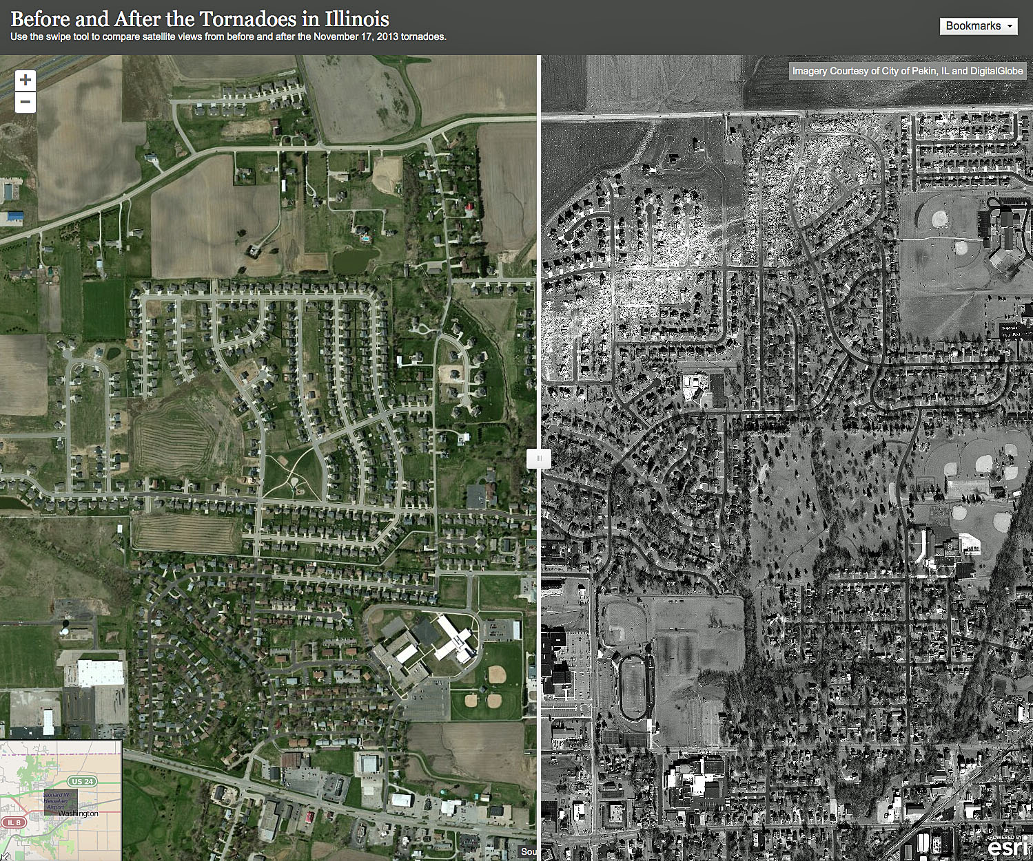

Figure 5- Example of GIS Displaying Imagery Before and After a Tornado

(Source – Esri; Imagery Courtesy of Pekin, IL and Digital Globe)

The GIS Resources and Staffing section of this SOG aids in identifying the resources and staffing recommended for a successful response. Content provided in that section should be considered optimum. Specific roles will depend on the size of staffing and the manner and extent to which GIS is implemented across state and local government. MACCs should develop their own GIS capabilities and rely on participating agencies for data and subject matter expertise related to their specific mission where appropriate. For most situations, GIS Team members will fill multiple roles. It is recommended that MACCs work with their state and local government agencies to identify these resources and develop relationships to have GIS responders report to (or collaborate with) the MACC if/when needed. It is also recommended that MACC officials and GIS professionals train together prior to incidents to better understand each other’s roles and the role they each play in a successful response. Recognizing that most local governments may have only one staff member with GIS capabilities, it is extremely important that templates, delivery schedules, and close coordination with the emergency managers, first responders and GIS professionals be established for tornadic events to maximize the benefits that GIS can provide.

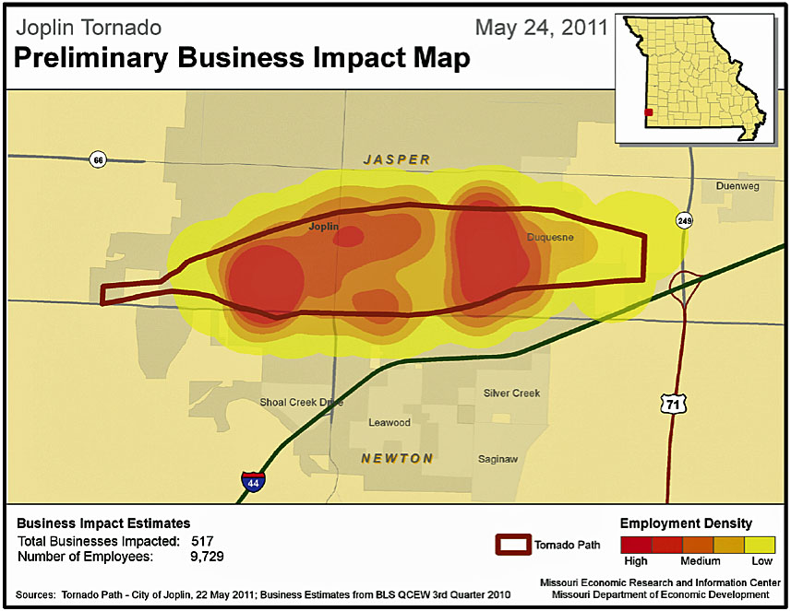

Figure 6- Preliminary Business Impact of Joplin Tornado

(Source – Missouri Emergency Management Agency)

If you don’t have adequate GIS resources, it is suggested that you contact your State GIS Coordinator. Your state’s coordinator will be able to guide you to available resources. A listing of State Coordinators is available at: <http://www.nsgic.org/state-representatives>. If there are not adequate GIS resources within your state, states have the option of obtaining additional resources from other states through the [Emergency Management Assistance Compact](http://www.emacweb.org). Contact officials within your State EOC to determine if and how that is an appropriate resource to meet your needs. (URISA’s GIS Corps (<http://www.giscorps.org>) may also be an option for agencies with no GIS resources or staff.)

Most important of all is to ensure that products delivered from the GIS system are relevant to and used by the emergency management staff to improve their decision-making. That requires that key emergency management staff and first responders meet with the GIS Team and identify their priorities in responding to a tornado. Next, decisions must be made on what GIS products can assist in those needs and when those products should (and can) be produced. After that, a production schedule should be established and great care must be taken to introduce those into the emergency management and first responder workflow via their standard operating procedures. Finally, regular scenario-based training (which emphasizes the use of the GIS products) should be undertaken (see Appendix 8), after action reporting developed and modifications to the procedures be adopted as required to ensure optimal performance by all.

## FEMA Emergency Management Institute

The DHS Geospatial Management Office (GMO) has developed a series of courses on the Homeland Security Geospatial Concept-of-Operations (GeoCONOPS) that identifies points of collaboration, best practices, technical capabilities and authoritative data sources. A course which is geared to helping Emergency Managers better understand the value of GIS in the EOC is: [IS-922: Applications of GIS for Emergency Management](http://training.fema.gov/is/courseoverview.aspx?code=is-922).

## NAPSG Quick Guide

For more information, please reference the NAPSG publication: A Quick Guide to Building a GIS for Your Public Safety Agency at the NAPSG website: <http://napsgfoundation.org/wp-content/uploads/2013/10/NAPSG-SOG-Quick-Guide-V3.pdf>.

# keys to the successful use of gis that emergency managers & first responders should know

The most important keys to a successful GIS-aided response are the integration of GIS generated information into the emergency management workflow, training, communication, cooperation, and understanding. This section discusses the key elements emergency managers and first responders need to understand in order most effectively take advantage of GIS during an event.

1. Have a GIS Team selected and trained (minimum ICS/IS-100.b, 200.b, IS-700.a and IS-103) prior to tornado season as well as familiarity with meteorological terminology (refer to Appendix 5) and weather related data products.
2. Meet with your GIS Team before your region’s major tornado season to explain the issues that you encounter during a tornado and agree on what GIS products can best assist you in meeting your emergency management needs. Agree on a schedule for the delivery of standard GIS products and a system for ordering unique GIS products.
3. Integrate the use of GIS products into your standard operating procedures/emergency management workflow.
4. Integrate the use of GIS into emergency management drills/scenarios prior to tornado season. Meet with the GIS Team subsequent to the drills to provide feedback and make adjustments to the standard operating procedures as required.
5. Provide regular communication with the GIS Team on emergency management and first responder needs, expectations and product delivery timetables.
6. Ensure appropriate hardware, software, Internet connectivity, servers, printers/plotters, supplies and IT staff support. Determine back-up systems in case of communication failures.
7. Provide the GIS professionals a clearly defined organizational chart so that they can understand the structure of the organization and whom they should report to during an emergency event.
8. Ensure that your GIS Team has access to regular training on GIS software/tools and your crisis information management system, if applicable.
9. Provide a space/room in the EOC or ICP for the GIS Team to work together/collaborate.
10. If possible, designate a GIS liaison (refer to GIS Roles and Responsibilities) to work with the emergency management staff to better understand their changing operational needs and suggest GIS support that can assist them in resolving their issues during the crisis.
11. Understand that GIS can be used for more than planning and is a valuable tool to provide situational awareness and focused response throughout all phases of an event. (Refer to “What types of questions GIS can answer?” in the previous section.)
12. Enable proper coordination with GIS professionals in neighboring jurisdictions and at state and Federal government agencies when appropriate.

# What GIS Professionals Need to Know About Emergency Management

In order to effectively respond to an emergency as a GIS professional, it is important to understand the various emergency management and incident command protocols that are in place. Not all Multi-Agency Coordination Centers (MACC’s) are alike. In many cases, the GIS responders to MACC’s may be unfamiliar with the layout, hierarchy, and processes taking place. Research how your agency’s Incident Command System (ICS) is structured. The organization’s organizational chart can be very useful. GIS responders may also want to refer to and become familiar with the Homeland Security Geospatial Concept of Operations (GeoCONOPS) (<http://www.geoplatform.gov/sites/default/files/geoconops/DHS_Geospatial_CONOPS_v6_SCREEN_140529.pdf>) if Federal Government agencies are to become involved. In addition, the DHS Geospatial Management Office (GMO) has developed a series of courses on the Homeland Security Geospatial Concept-of-Operations that identifies points of collaboration, best practices, technical capabilities and authoritative data sources. These courses are geared toward technical personnel supporting operations centers at State and local government. They can be found on the FEMA Emergency Management Institute website: <https://training.fema.gov/EMIWeb/IS/courseOverview.aspx?code=IS-60>, <https://training.fema.gov/EMIWeb/IS/courseOverview.aspx?code=IS-61>, and <https://training.fema.gov/EMIWeb/IS/courseOverview.aspx?code=IS-62>.

## Homeland Security GeoCONOPS

The **Homeland Security (HLS) Geospatial Concept of Operations (GeoCONOPS**) is a “strategic roadmap to understand, and improve, the coordination of GIS activities across the entire spectrum of the Nation: from federal, to state, and local governments, to private sector and community organizations, academia, the research and development industry and citizens in support of Homeland Security and Homeland Defense (HD).“[[4]](#footnote-5) The intended audience for this document is the “entire GIS community within the Homeland Security Enterprise that supports the missions of the federal government under The Stafford Act, the National Response Framework (NRF), Presidential Policy Directive-8 (PPD-8) and Presidential Policy Directive-21 (PPD-21)”[[5]](#footnote-6). This includes stakeholders and actors representing the Emergency Support Functions (ESFs), the Joint Field Offices (JFO), Federal Operations Centers, the disaster preparedness exercise and evaluation community, and those involved in other NRF missions. To obtain a copy of the Homeland Security GeoCONOPS visit: <http://www.geoplatform.gov/sites/default/files/geoconops/DHS_Geospatial_CONOPS_v6_SCREEN_140529.pdf> or visit the Homeland Security GeoCONOPS Website at: <https://www.geoplatform.gov/geoconops-home>.

## Emergency Management Systems

Emergency management systems are policy documents with the purpose of guiding agencies on their internal organizational structure when responding to an event. They offer an operational foundation for emergency management organizations. They also provide the flexibility for expansion and integration with other levels of government should the need arise.

NIMS

The **Department of Homeland Security (DHS) released the National Incident Management System (NIMS) in March 2004**. It describes NIMS as follows: “The National Incident Management System (NIMS) provides a systematic, proactive approach to guide departments and agencies at all levels of government, nongovernmental organizations, and the private sector to work seamlessly to prevent, protect against, respond to, recover from, and mitigate the effects of incidents, regardless of cause, size, location, or complexity, in order to reduce the loss of life and property and harm to the environment. NIMS works hand in hand with the National Response Framework (NRF). NIMS provides the template for the management of incidents, while the NRF provides the structure and mechanisms for national-level policy for incident management.”[[6]](#footnote-7)

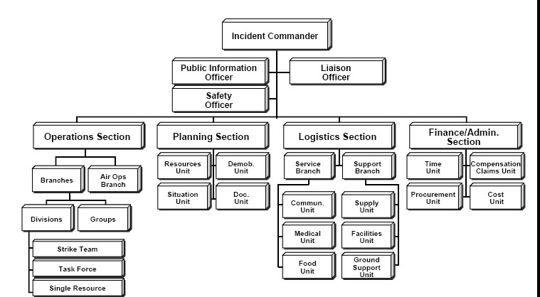

Figure 7-Example of an ICS Organizational Structure

(Source – Wikipedia)

ICS

The **Incident Command System (ICS)** is a command structure set up in the field for first responders. Some of these command systems have GIS staff. ICS provides a flexible mechanism for coordinated and collaborative incident management for first responders. The physical location where the ICS is set up is called the Incident Command Post (ICP). If you are requested to respond to or drop off information to the ICP, the following organizational structure will provide general assistance in identifying the right people. However, as ICP’s can be set up in different manners, it is recommended that you discuss its specific organizational structure with your ICP supervisor upon arriving there. For more information about ICS see: <http://www.nrt.org/production/NRT/NRTWeb.nsf/AllAttachmentsByTitle/SA-52ICSUCTA/$File/ICSUCTA.pdf?OpenElement>

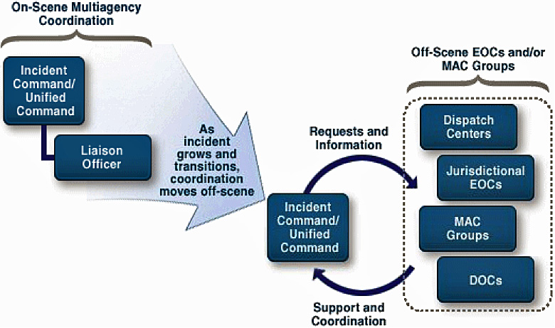

Figure 8-FEMA Multi-Agency Coordination System Diagram

(Source – NAPSG)

Multi-Agency Coordination System  
FEMA characterizes multi-agency coordination as a process that allows all levels of government and all disciplines to work together more efficiently and effectively. Often, cooperating agencies develop a **Multiagency Coordination System (MACS)** to better define how they will work together and to work together more efficiently; however, multiagency coordination can take place without established protocols. MACS may be put in motion regardless of the location, personnel titles, or organizational structure. MACC’s such as Emergency Operations Centers (EOC’s) and Department Operations Centers (DOC’s), etc. are part of several system elements included within the MACS. EOC’s and DOC’s are intended to facilitate MACS functions, and may provide support to Area Command, Incident Command, or Unified Command when resource needs exceed local capabilities.

## Emergency Operations Center

NIMS defines **Emergency Operations Centers (EOC’s)** as a component of a MACS. EOC’s do not have to be organized around ICS. NIMS states, "EOC’s may be organized by major discipline (e.g., fire, law enforcement, or emergency medical services); by emergency support function (e.g., transportation (ESF-1), communications (ESF-2), public works and engineering (ESF-3), or resource support (ESF-7)); by jurisdiction (e.g., city, county, or region); or, more likely, by some combination thereof. Incident Command Posts need reliable communication links to EOC’s to ensure effective and efficient incident management.” Some EOC’s can be mission-oriented and reside within the organization responsible for an Emergency Support Function (ESF). Personnel representing multiple jurisdictions and functional disciplines and a wide variety of resources may staff EOC’s. An EOC is activated to support the on-scene response during an escalating incident by relieving the burden of external coordination and securing additional resources. It is the physical location

**GIS**

Fire Services Coordinator

EAS Room

Radio Room

**R.A.C.E.S.**

Audio/ Visual Hardware - Plotters

**Joint Information Center (JIC)**

**211 – Public Inquiry**

**Policy**

**Video Wall Display (3)**

**Law**

**Fire/Health**

**Const. & Engineer.**

**Care & Shelter**

**Ops Chief/ EOC Director/ Recovery**

**Logistics**

**Plans**

**Liaisons**

Operations

**Information and Intelligence**

Figure 9-Example of the Physical Layout of an Emergency Operations Center

(Source – NAPSG)

where organizations and agencies come together during an emergency to coordinate response and recovery actions and resources. An EOC is often an established, physical location that is set up as an operations center. During an event, smaller incident command posts (ICPs) are often established. ICPs can be set up anywhere-a high school gymnasium or a mobile command facility in a parking lot.

***<<State/Regional/Local System Name>>***

***<<Include a description or reference to state, regional, or local systems or documents that impact emergency operations in the area>>***

## Emergency Management Assistance Compact

The **Emergency Management Assistance Compact (EMAC)** was established in 1996 and was the first national disaster relief compact since 1950 to be ratified by Congress. During a governor-declared state of emergency, EMAC offers assistance through the sending of personnel, equipment and commodities to aid disaster relief. All 50 States, the District of Columbia, Puerto Rico, Guam, and the U.S. Virgin Islands are EMAC members. EMAC allows affected states to join together and help one another during a disaster and provides a methodology for those states receiving assistance to pay those states providing assistance. For more information on EMAC see: <http://www.emacweb.org>. (Please note that State EOC’s are responsible for requests for assistance through the EMAC process.)

## International Charter

The **International Charter** provides a unified system of space data acquisition. It delivers that data from various space-based platforms that are related to the areas impacted by disasters. This includes both man-made and natural events. The services are provided to authorized users, using a secure system. The International Charter is comprised of over 20 agencies, which have committed to provide various resources, at no cost, to support the International Charter for major events. For more information about the International Charter see: <http://www.disasterscharter.org> and your State GIS Coordinator/GIO at: <http://www.nsgic.org/state-representatives>.

## Crisis Information Management Systems

Crisis information management systems are systems and viewers designed to manage information flow during an incident. Typically, these are web-based crisis information management systems that provide a secure, log-on platform for emergency managers and first responders to share real-time critical information, and can perform basic mapping and analysis during an incident. Examples of these systems include: WebEOC, e-Team, Disaster LAN, and Knowledge Center. (These are commercial products designed to provide a User Defined Operating Picture.)

Many emergency managers and first responders have utilized a User Defined Operating Picture(UDOP) (sometimes referred to as a Common Operating Picture or COP) during an incident. A UDOP is a single viewer that contains relevant GIS data (such as the path of a tornado, populations and businesses most likely to be impacted, evacuation zones, evacuation routes, etc.) and tools that several different command centers or groups can utilize during an incident. Your individual agency may have an established UDOP in use. (Several examples of state UDOP’s are available in Appendix 4.) It is important for GIS personnel to be aware of its existence and become familiar with its functionality well before an event. If a UDOP is not already available, GIS staff should consider creating one.

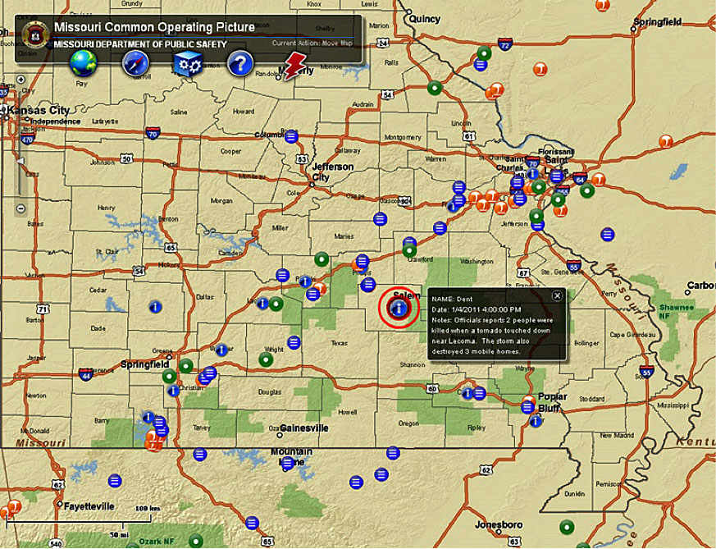

Figure 10- Missouri U.D.O.P. Displays N.W.S. Storm Reports of a Deadly Storm

(Source – Missouri Emergency Management Agency)

With the advent of cloud computing and the need to integrate various sensors and mobile devices into a UDOP, GIS technology is moving towards the use of anunderlying infrastructure platform that data, tools and various applications are built upon. Examples include Esri’s ArcGIS Server or ArcGIS Online, Google Earth or equivalent open source software built to Open Geospatial Consortium (OGC) standards. It has the capability to manage content and operations, display situational awareness, engage the public, gather data and share content. The most powerful capability provided by a UDOP is the ability to push the content to many different target applications and technologies. The information can be used on a computer, through a mobile (tablet or smartphone) application, or a web-based viewer. This allows emergency managers and first responders to be completely mobile and take their response efforts out of the command center, and creates an environment that all responders involved can utilize.

## Glossary of Emergency Management Terms and Definitions

In order to successfully communicate in an emergency management environment, GIS professionals need to understand emergency management terms. Appendix 3 provides a listing of terms and definitions. Appendix 2 provides a listing of emergency management acronyms. (Please note that each agency may have additional acronyms that you should be familiar with.)

# keys to the successful use of gis FOR A TORNADO EVENT that gis professionals should know

The most important keys to a successful GIS aided response are integration of GIS into the emergency management workflow, training, communication, cooperation, and understanding. GIS professionals also need to understand what data, software and hardware are keys to a successful incident response. This section discusses the key elements that a GIS professional needs to understand during an event.

## Critical Actions and Activities

There are several critical actions and activities that GIS professionals must undertake to ensure that GIS is successfully implemented and “used” in response to and recovery from a tornadic event.

1. Assessing emergency management and first responder needs – If you are establishing GIS in an EOC for the first time, it is essential that you hold a series of meetings with emergency managers and first responders to fully assess their needs and to explain where (and how) GIS can “best” assist them in their response and recovery needs. Your message on GIS should be non-technical and concise. In some cases, you may be using this as an opportunity to “sell” the use of GIS to the staff. The goal of your meetings is to develop a clearly defined statement of what GIS products will be produced, what time frame they will be produced in, and how the emergency management and first responder staff will be expected to use them. All products should be labeled in easy-to-recognize, non-technical terminology.

If you already have a GIS system in place in your EOC, it is suggested that you enter into a shortened version of this process on an annual basis to insure that you are continuing to meet the needs of staff, learn of services/products requiring improvement, update data as needed and solicit new ideas from them as they become more familiar with the GIS capabilities and products. You should also use this opportunity to update them on changes to GIS capabilities and the potential that those changes provide for meeting their needs.

1. GIS Products – Examples of common GIS products include: path of the storm; impacts on population, businesses, and critical infrastructure; search and rescue zones (and staff assigned to them); search and rescue progress; potential hazards in the impacted area; hazards found in the field (live electrical lines down, gas or other hazardous material leaking); populations needing assistance; evacuation zones; security perimeter; evacuation routes or access points; locations of shelters; imagery of post-storm impacts; locations of emergency responders and equipment in the field; and the value of damages sustained by property in the impacted area.

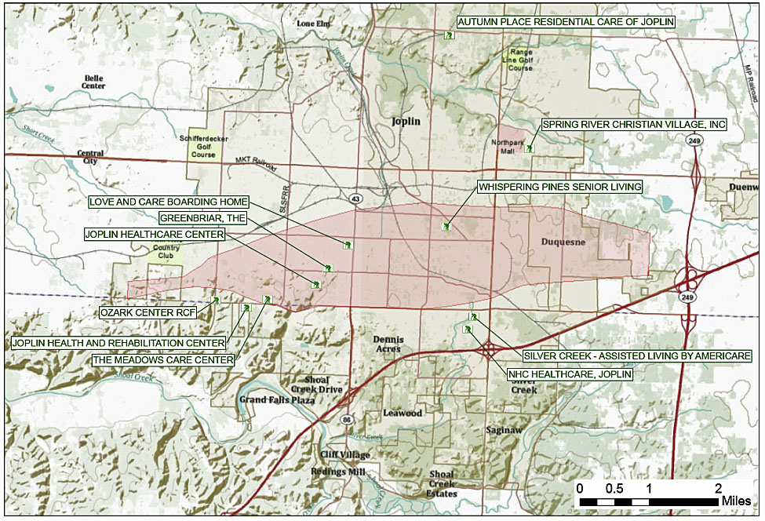

Figure 11- Nursing Homes in the Damaged Area of the Joplin Tornado

(Source – Missouri Emergency Management Agency)

GIS professionals must also remember that GIS is more than a map. While paper (or digital) maps are powerful visual tools that meet a number of needs, GIS can be used for so much more than static mapping. It is important to ensure that the products produced are useful to the incident command staffs’ diverse assignments and operational needs. In some instances, a simple list of items or a derived value can be all that is needed (i.e. phone numbers of facilities in the impacted area might be quicker and/or more useful to emergency management staff needing to make calls than having a map depicting those facilities). GIS can contribute important information throughout the emergency management response cycle. It is important to regularly demonstrate to emergency managers and first responders the multiple ways that GIS can be used to assist them during an incident. GIS analysis can be used beyond its basic function in other ways such as: temporal displays (fly-throughs and animation), spatial dataset reporting, form generation, rapid field reporting (using mobile devices which allow data to be uploaded to the server in real-time and pushed back to the field crews), spatial division of labor, GeoPDF® production, and geo-referencing photographs. Finally, GIS can be used to harvest pictures and reports from individuals provided through social media to provide a more comprehensive perspective of the overall picture after a tornado. The GIS Team may be called upon to assist with tracking urban search and rescue operations, calculating the amount/cost of debris removal or level of damage/cost of structures impacted, or analyzing the economic impact of the storm on businesses in affected areas (refer to Figure 6 - Preliminary Business Impact of Joplin Tornado).

1. Standardize GIS Products – The GIS Team, emergency managers, and first responders should jointly decide which products will be produced on a regular schedule and which will be available, but must be requested on an individual basis. The established schedule must reflect both needs of the users (of paramount importance), and the realistic capabilities of the GIS professionals. It should also be published as a GIS “product catalog” and inserted into the standard operating procedures for tornado response and recovery. In addition, a system for ordering GIS standard products and/or unique products should be documented and distributed throughout the EOC. This should include a request form for documenting all aspects of the request, the person making the request, and the expected delivery time.
2. Data – Once the GIS Team knows the standard products that it will be producing, it must ensure that it has access to the data needed to create those products. As a general rule, all “basemap” data (refer to the subsection entitled, “Essential Elements of Information” for additional information and/or Appendix 7) should be up-to-date and available within the EOC. Events can change rapidly and it is essential to have all data (local data, in particular) on hand to address any issues or requests as they arise. If the EOC loses connectivity to any web services or other external data sources, the GIS Team will still be able to function. (If your organization has a failover system in place for its servers, see if the GIS servers can be included in that.) Nevertheless, cloud-based data storage should be considered for data back up. Where necessary, make certain that data sharing agreements are in place prior to tornado season to insure that the EOC has the latest and most accurate data.

Next, the GIS Team needs to establish what “event” related data is required and how best to obtain that data. Establishing a preliminary tornado path and the area of damage quickly is paramount. While the National Weather Service typically provides a verified depiction of the tornado’s path within 24–48 hours after an event, its timing is not necessarily adequate for response efforts at the local government level. Other services/models available from the National Weather Service are rapidly improving and should be monitored to determine how that can be of assistance. The GIS Team should meet with the local office to ensure they your needs and how best to provide the data to you. Imagery is ideal and may be available from local news stations, volunteers or the Civil Air Patrol. “Boots on the ground” is, perhaps, the methodology most used at the local government level to quickly assess the tornado’s path. This may be as simple as geo-referenced photographs uploaded to the EOC. More valuable data may be provided by using electronic forms given to trained volunteers that are accessible via a mobile device and uploaded to the EOC (this can also be done via a paper form). Such systems can also be used to depict search and rescue progress, structural damage evaluation, and identifying the location of hazards within the event perimeter. In all cases, agreement must be reached with emergency managers and first responders on how to best perform this data collection. Then, staff or volunteers to perform this work must be identified and properly trained. (One local government GIS professional indicated that he provides paper maps and “sharpies” to his local firemen who mark up the document as best as possible. Then, he takes that information heads into the field with a trusted colleague and GPS devices to map out the storm’s path as quickly as possible. He noted that this provides him with the most efficient means of determining a preliminary tornado path.) Social media is also a method of determining the impact of a storm. The de facto standard for obtaining the latest Twitter information is #OKWX (instead of “OK” use the 2 letter abbreviation of the state that has been impacted by the storm.) When possible, the GIS analyst should review the observations being provided there.

1. Hardware, Software and Connectivity - Determine the proper bandwidth necessary to support GIS operations. Work with the IT staff to ensure appropriate Internet connectivity, servers, printers/plotters, security, and any other equipment are made available. Inadequate or unstable bandwidth or missing key equipment will severely degrade operations. Communicate these requirements to management **long before tornado season** so that steps can be taken to mitigate these needs. It is important to note that, even with the best planning, sometimes what is needed is not available during a crisis. Establish a risk avoidance plan with management that identifies what to do without various key items/services that have high probabilities of failure. (Some of these requirements may be determined through drills and scenario-based exercises.)
2. Efficiency – Key to being successful in producing GIS products is the development of an efficient methodology to create the products in a timely manner. GIS professionals should create “templates” and document the best methodology for creating each of the standardized GIS products. This methodology should include location of the appropriate base data as well as linkages to storm related data. It is not necessarily efficient to focus on cartographic elements, such as colors, subtle variations in line weights, etc. Keeping the message clear and simple is critical! Testing the templates through numerous training exercises will provide GIS professionals the information necessary to determine how to best represent the information they have been asked to depict. This will result in quicker production at the time of the incident.
3. Timing is essential – The need to produce products in a timely manner cannot be overstated! During an incident it is important to deliver priority information as quickly as possible, but it is “crucial” to deliver the scheduled, standardized products on time to ensure that they will be consistently used in the emergency management and first responder decision making and workflow processes. For requests outside the standardized products, discuss with the requestor the feasibility and time frame of fulfilling the request, or alternate solutions that may be completed in a more timely fashion. While it is imperative that products be accurate, GIS professionals must remember that their work is time-sensitive for decision makers. **If GIS products are not delivered in a timely manner in an emergency, important decisions will be made without them!** When conflicts in the timing of deliveries occur, you must work with the emergency managers and first responders to prioritize their needs.
4. Make the message easy to understand – Keep map products, presentations, situational reports and briefings straightforward and clear. Bold graphics are often preferred when meeting with first responders. GIS professionals may not be working with individuals who are familiar with the technical terminology of GIS. It is most productive to focus on the subject matter being depicted instead of the technical aspects of the work. Avoid GIS/technology acronyms! Side-by-side scenario exercises with emergency managers will help to address this issue. It is particularly important that products are clear and unambiguous when they are slated for use by the general public.
5. Incorporating the use of GIS products into the EOC’s Standard Operating Procedures – None of the previously mentioned activities will be fully successful if the use of the GIS products is not incorporated into the standard operating procedures for the emergency managers and first responders. Work with both parties to ensure that their benefits are properly utilized for decision-making and then “memorialized” in their procedures. For State EOC’s, keeping track of the status of emergency declarations that have been received from municipal or counties/parishes subsequent to a tornado should be memorialized to insure accurate tracking of funding requests throughout the process.
6. Metadata – During an event you will most likely not have the time to create extensive metadata. Provide metadata that is as complete as feasible. It is recommended that metadata templates be established. It will help others to understand the data, use it in the best way possible and help reduce the chances for duplication. Minimal metadata should include basic information such as the incident name, description, source of the data, a contact person, the date and time it was created/collected and any limitations the data may have.
7. Archive products produced – Archive each product produced as a PDF indicating (on the document) the date and time it was distributed as well as its file path/location. Maps can be stored in document and PDF formats and shared and used as documentation. Data should be time-stamped at the record or database level. These will be invaluable tools, later, to determine what was happening and when. If you are using a COP, take a current screen shot throughout the event to document the current data displayed on the map.
8. Product tracking mechanism – Develop a mechanism (spreadsheet or database) to track the status of scheduled products and specialized requests. Make this information easily available to emergency managers and first responders. In addition, use this to review the status of GIS products during shift transitions. After an event has concluded, use this information to determine how and where to make improvements in GIS product delivery.
9. Product distribution – Develop a well-known file location that is easily accessible by emergency managers and first responders to house completed GIS products. Ensure that notifications are provided to the appropriate users with the community when products are available there. In addition, consider having a consistent location within the Situation Report that indicates which products were completed and are available for use.

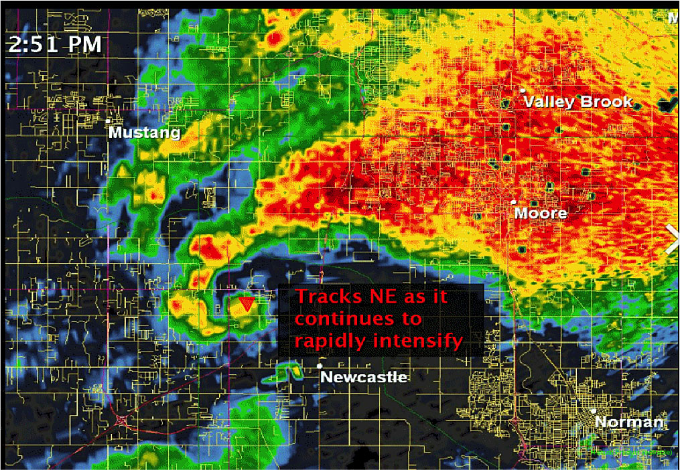

Figure 12-Radar Images of the Moore Tornado with a [Debris Ball](http://en.wikipedia.org/wiki/Debris_ball) and Signature Hook Echo

(Source – Wikipedia)

1. Scenario based training – As noted previously, tornadoes strike suddenly often with devastating effects. In order to be successful in the use of GIS to assist emergency managers and first responders, all aspects of execution must be prepared in the months prior to tornado season. (Refer to “Standing Orders” in the following section as well as the scenario training for local governments in Appendix 8.) In addition, the skills of production and the use of GIS in operations must be “honed” through scenario-based training with the GIS Team and the emergency management and first responders. After Action Reports specifically for the GIS Team should be created after each training and adjustments to GIS products and emergency management and first responder procedures made to ensure the best outcomes for all.
2. Communication is critical during a response. It is important to:
   1. Communicate on all levels with management and requestors about expectations, needs, and products available as well as ingestion and distribution capabilities versus needs.
   2. Understand the ICS organization chart in place during the event. (This allows the GIS professional to know who to go to for information, permission, and questions, and ensures that the information is coming from and going to the correct people. It also helps with the command staff needs and workflow.)
   3. Create a staff list with contact information and shift preference pre-event that can be used during the response. In addition, create a list of GIS professionals with contact information in bordering jurisdictions that can be used if necessary.
   4. Establish and implement standard symbology for map presentations (this will reduce confusion and avoid problems created by incorrect interpretation of data). Refer to NAPSG’s work on incident symbology (<http://www.napsgfoundation.org/resources/>).
   5. Establish a procedure for documenting, processing, tracking standard products and making ad hoc requests. Be sure to clearly communicate that with management and likely requestors.
   6. Conduct regular GIS Team communication. Coordinate with relevant parties on partner tools and their integration. It is essential for GIS Team members to clearly understand their roles and establish realistic expectations for GIS Team members, emergency managers and first responders.
   7. Coordinate GIS efforts with local, State and Federal government GIS professionals where appropriate. When possible, share work products to eliminate duplication of effort.

# Standard Operating Procedures for Tornadoes

This chapter discusses the main components involved in preparing for and responding to a tornado. It includes examples of standing orders for a GIS Team, a pre-event checklist, GIS staffing and resource requirements, mapping and data protocols and metadata guidelines among other elements. In addition, NOAA is developing a number of tornado related products through its Storm Prediction Center (<http://www.spc.noaa.gov/aboutrss.html>). These examples should provide a GIS Team with a head start in the preparations needed to ensure that they meet the needs of the EOC. Modifications to each should be made to reflect the specific needs of the emergency management and first responder staff at your EOC.

## GIS Team Preparation Checklist

This document provides a general checklist (located in Appendix 1) which sums up what steps should be taken to fully prepare a GIS for a tornado. This checklist should be used as a guideline, and customized by individual organizations to best suit their mission during to emergency events.

## GIS Team Standing Orders for a Tornado

**Example – GIS Team Standing Orders for a Tornado:**

The following standing orders provide the reader with an idea of the kinds of actions, products and models that are available and should be considered when providing support to an EOC. These should be adjusted to reflect the needs of your State or community. The example provided assumes that the team will have access to a website and web services.

The GIS Team Standing Orders for a tornado provided herein draws from the standing orders for the Florida Division of Emergency Management’s GIS Unit for coastal storms. Because tornadoes can strike quickly and with little warning, the need for long-term preparation and practice to allow GIS to be effectively used for an event cannot be overstressed. As a result, there are a number of tasks that a GIS Team can undertake to assist the EOC in their efforts to be fully prepared for the response to and recovery from a tornadic event.

## Example - GIS Team Standing Orders Tornado – Pre-Impact

|  |  |
| --- | --- |
| **T-6 Month Crosscheck** |  |
| ***Tasks:*** | ***Responsible/Complete*** |
| Work with emergency managers to develop a GIS presence/GIS Team within the EOC | GIS Team Leader |
| Review historical tornado data for your area and state including damage/loss data | GIS Team |
| Review checklist (Appendix 1) and CARAT (<http://www.napsgfoundation.org/carat/>). Determine deficiencies and establish action plan to overcome them. Work with the GIS Team and the emergency managers to address deficiencies | GIS Team Leader |
| Meet with the Director of Emergency Management Operations and first responders to define their needs and incorporate the use of GIS products into their planning, operational response and recovery efforts for tornadic events. Agree on GIS products to be provided | GIS Team Leader |
| Establish a schedule for GIS product delivery that matches emergency management needs | GIS Team Leader |
| Locate appropriate base data | GIS Analyst |
| Establish data and product sharing agreements/protocols with State and appropriate local governments where required | GIS Team Leader |
| Work with emergency managers and first responders to identify the best ways to obtain data from “boots on the ground” on the tornado path and post tornado impacts | GIS Team Leader |
| Develop data collection forms and methodologies (both paper and digital). Establish separate data collection teams to provide data on the storm path and evaluating storm impacts. Insure that data on storm impacts is aligned with FEMA requirements (see Figure 26) | GIS Analyst |
| If feasible, determine how to quickly obtain imagery of impacted sites | GIS Team Leader |
| If feasible, determine how to use social media sites to receive data | GIS Team Leader |
| Develop templates to provide GIS products within the product delivery schedule | GIS Analyst |
| Develop system for distribution of “scheduled” products to emergency managers and first responders | GIS Team Leader |
| Develop a system for requesting and tracking all GIS products | GIS Team Leader |
| Determine where the data should be stored for easy access. (Storage should be on-site as well as offsite (cloud) for backup) | GIS Team Leader |
| Study crowd sourcing inputs. Decide how they could/should be used to obtain actionable data | GIS Analyst |
| Develop map books for your community/region/state. Work with the first responders to determine the best method and material to use for initial deployment. | GIS Analyst |
| Download NOAA’s Weather and Climate Toolkit (<http://www.ncdc.noaa.gov/wct/>) as well as other weather related tools and RSS feeds (<http://www.spc.noaa.gov/aboutrss.html>) | GIS Analyst |
| Practice with these tools within the GIS Team and determine the most appropriate to meet your needs | GIS Team |
| Meet with your local office of the National Weather Service to discuss the latest tools available as well as the need to capture data on the path of the tornado as soon as possible. Work with them to determine the most expeditious method to capture that data from them after an event occurs. | GIS Team Leader |
| Initiate scenario based training within the GIS Team | GIS Team Leader |
| Modify templates and other methodologies to insure efficient delivery of GIS products. | GIS Analyst |
| **T-3 Month Crosscheck** |  |
| ***Tasks:*** | ***Responsible/Complete*** |
| Train volunteers on data collection methodology using new forms created as well as on uploading geo-referenced photographs, etc. | GIS Team Leader |
| Establish a schedule for scenario training within the GIS Team | GIS Team Leader |
| Practice delivering the scheduled GIS products within the stated time frames | GIS Team Leader |
| Develop a GIS Team After Action Report | GIS Team Leader |
| Review the results with the GIS Team. Make adjustments to templates, workflows, etc. as required | GIS Team Leader |
| Work with the emergency managers and first responders to insure that the “use” of GIS products is incorporated into their standard operating procedures | GIS Team Leader |
| Establish a schedule for scenario training with emergency managers and first responders to “memorialize” the use of GIS products within their workflows | GIS Team Leader |
| Compile contact data of GIS resources from State/local/ private sectors. Contact the State GIS Coordinator for assistance in this effort. | GIS Team Leader |
| Ensure all data is collected and stored in a manner that is easily retrievable by whomever needs it during an emergency | GIS Database Manager |
| Test to insure all data and tools are available and working | GIS Analyst |
| Report findings to GIS Team Leader. Make modifications where required | GIS Analyst |
| Initiate scenario based training with emergency managers and first responders | GIS Team Leader |
| Develop a “GIS Team” After Action Report | GIS Team Leader |
| Review the “GIS Team” After Action Report with the GIS Team and emergency managers and first responders; modify the templates, delivery schedule and/or the emergency management SOP’s to improve its effectiveness | GIS Team Leader |
| Conduct at least one scenario based training session with emergency managers and first responders (include after impact data collection) and work with the local NWS office | GIS Team Leader |
| **T-1 Month Crosscheck** |  |
| ***Tasks:*** | ***Responsible/Complete*** |
| Conduct at least one scenario based training session with emergency managers and first responders (include after impact data collection) and work with the local NWS office | GIS Team Leader |
| Complete an After Action Report on GIS effectiveness; review the results with emergency managers and first responders. Modify the report as required. Review the results with the GIS Team. Devise and execute an action plan to remedy outstanding issues. | GIS Team Leader |
| Check the National Weather Service’s (NWS) Storm Prediction Center (SPC) forecasts containing areas of expected thunderstorm occurrence and expected severity (<http://www.spc.noaa.gov/aboutrss.html>). Refer to the convective outlook | GIS Team Leader |
| Insure that relevant data and data models are available | GIS Analyst |
| Test templates to insure that their current versions work with the current data available | GIS Analyst |
| **During Tornado Season** |  |
| ***Tasks:*** | ***Responsible/Complete*** |
| Practice delivering the scheduled GIS products within the stated time frames monthly | GIS Team Leader |
| Develop a GIS Team After Action Report | GIS Team Leader |
| Conduct at least one scenario based training session with emergency managers and first responders (include after impact data collection) and work with the local NWS office | GIS Team Leader |
| Complete an After Action Report on GIS effectiveness; review the results with emergency managers and first responders. Modify the report as required. Review the results with the GIS Team. Devise and execute an action plan to remedy outstanding issues | GIS Team Leader |
| Check the National Weather Service’s (NWS) Storm Prediction Center (SPC) forecasts containing areas of expected thunderstorm occurrence and expected severity. Refer to the convective outlook. Check for tornado watches or any tornado warnings | GIS Analyst |
| Notify emergency management staff of tornado watches, warnings, sightings, etc. | GIS Team Leader |
| Provide maps of tornado watch areas | GIS Analyst |
| Notify emergency management staff of tornado warnings | GIS Team Leader |
| Provide maps of tornado locations | GIS Analyst |
| If available through the NWS, track activity through Doppler Radar: <http://radar.weather.gov/GIS.html> | GIS Analyst |
| Check for hail and a debris ball via: <http://www.spc.noaa.gov/climo/reports/>. Information on warnings, storms reports, etc. can also be found at: <http://weather.im/iembot/>. | GIS Analyst |
| When approved, place GIS Team on alert | GIS Team Leader |

Figure 13- GIS Team Standing Orders for a Tornado - Pre-Event

(Source – NAPSG)

## Example - GIS Team Standing Orders Tornado – Post-Impact

|  |  |
| --- | --- |
| **0 hrs. Crosscheck** |  |
| ***Tasks:*** | ***Responsible/Complete*** |
| Assemble the GIS Team | GIS Team Leader |
| Initiate data collection protocols | GIS Team Leader |
| Initiate GIS product output schedule as well as product tracking system | GIS Team Leader |
| Provide maps of hazardous materials, etc. for search and rescue | GIS Analyst |
| Provide map books for search and rescue efforts | GIS Team Leader |
| Coordinate with emergency managers and first responders on updates to depict search and rescue products | GIS Analyst |
| Check for video and other imagery from event | GIS Analyst |
| Check for data from on-site volunteers and social networks to depict tornado path and impacts | GIS Analyst |
| Contact local NWS office to determine what data they can make available | GIS Team Leader |
| Contact State Emergency GIS contact to alert them of your actions | GIS Team Leader |
| **T+12 hrs. Crosscheck** |  |
| ***Tasks:*** | ***Responsible/Complete*** |
| Contact local NWS office to determine what additional data they can make available | GIS Team Leader |
| If approved, contact GIS professionals in surrounding jurisdictions and State, EOC’s to coordinate efforts | GIS Team Leader |
| Coordinate with emergency managers and first responders on updates and distribute revised search and rescue products. If appropriate, modify map books to provide large-scale maps of impacted areas. | GIS Analyst |
| Determine volume of population impacted and needing shelter requirements; provide information to Operations and PIO for distribution to public as appropriate | GIS Analyst |
| Delineate evacuation zones, shelters, etc. | GIS Analyst |
| Provide GIS products depicting security perimeters, vehicular access points and access routes, etc. | GIS Analyst |
| **T+24 hrs. Crosscheck** |  |
| ***Tasks:*** | ***Responsible/Complete*** |
| Contact local NWS office to determine what additional data they can make available | GIS Team Leader |
| Coordinate with emergency managers and first responders on updates and distribute revised search and rescue products | GIS Analyst |
| Provide updates on debris removal quantities and costs | GIS Analyst |
| Coordinate with updates on evacuation zones and shelters | GIS Analyst |
| Meet with emergency management operations staff to determine how GIS products are being used and whether new products or modifications to existing ones are required | GIS Team Leader |

|  |  |
| --- | --- |
| **T+36 hrs. Crosscheck** |  |
| ***Tasks:*** | ***Responsible/Complete*** |
| Contact local NWS office to determine what additional data they can make available | GIS Team Leader |
| If necessary, revise destruction levels and costs of the tornado’s impact | GIS Analyst |
| Provide updates on debris removal quantities and costs | GIS Analyst |
| Coordinate with updates on evacuation zones and shelters | GIS Analyst |
| **T+48 hrs. Crosscheck** |  |
| ***Tasks:*** | ***Responsible/Complete*** |
| Contact local NWS office to determine what additional data they can make available | GIS Team Leader |
| If necessary, revise destruction levels and costs of the tornado’s impact | GIS Analyst |
| Provide updates on debris removal quantities and costs | GIS Analyst |
| Coordinate with updates on evacuation zones and shelters | GIS Analyst |
| **T+72 hrs. Crosscheck** |  |
| ***Tasks:*** | ***Responsible/Complete*** |
| Update debris removal quantities and costs | GIS Analyst |
| If necessary, revise destruction levels and costs of the tornado’s impact | GIS Analyst |
| Coordinate with updates on evacuation zones and shelters | GIS Analyst |
| Coordinate with emergency managers and first responders on updates and distribute revised search and rescue products | GIS Analyst |
| **Post Event** |  |
| ***Tasks:*** | ***Responsible/Complete*** |
| Perform final After Action Report on GIS effectiveness | GIS Team Leader |
| Modify GIS products and/or schedule to improve emergency manager and first responder capabilities | GIS Team Leader |
| Modify emergency manager and first responder standard operating procedures as required to ensure the most effective use of GIS for their planning, response and recovery efforts | GIS Team Leader, Emergency Managers and First Responders |

Figure 14-GIS Team Standing Orders for a Tornado – Post-Event

(Source – NAPSG)

## GIS Resource & Staffing Requirements

**Background:**  This chapter details the physical resources and personnel skill sets required for GIS responders to fulfill GIS needs and expectations in an emergency event. Potential GIS responders should be identified and trained prior to an incident.

Not all Multi-Agency Coordination Centers (MACC’s) are alike. Please be sure to modify the sections and examples below to fit your MACC needs. Some MACC’s may have a GIS Unit within the Planning Section, while some may have a GIS Branch within the Intel/Info Section of the National Incident Management System (NIMS) structure. The GIS Staffing Requirements section is also solely provided as an example. It should be modified based on your jurisdictional needs and be scalable based on the size of the jurisdiction as well as the size of the incident.

GIS staff expectations & team structures should be clearly identified well before tornado season. Potential GIS responders should be made aware of these expectations before agreeing to become a GIS responder. In a MACC, the environment during an incident can be very frantic with requests for information and maps coming from a variety of people and disciplines. Responders are also expected to work long hours while keeping a high performance level and intensity. Some outstanding GIS professionals may not function well in this type of environment, and, therefore, may not be ideal candidates as GIS responders. It is recommended that GIS staff conduct internal scenario-based exercises prior to an incident to educate the GIS Team on the expected pace and demands of incident response and to determine the roles for which team members are best suited. Because most tornadoes involve local EOC’s, it is likely that the local GIS Team may consist of 1 or 2 staff. If that is the case, it is recommended that as much advanced planning be undertaken as possible to ensure maximum efficiency.

It is also very important that emergency management and first responder personnel are educated on the GIS information that can and should be integrated into their workflows. Conducting exercises and cross training for GIS personnel is an important part of implementing your agency’s SOPs.

**Example GIS Supply List**

The table that follows serves as an example for the “GIS Supply List”. The needs and availability of resources for each agency or jurisdiction will vary. Use this list as a guiding example and not as a fixed set of requirements.

***Purpose:*** This chapter details the resources and skill sets required for GIS Responders to fulfill GIS needs & expectations in an emergency event.

### Resource Requirements

|  |  |  |  |  |  |
| --- | --- | --- | --- | --- | --- |
|  | **REQUIRED** | | **Location** | | |
| **Office** | **Field** | **Primary** | **Secondary** | **Tertiary** |
| CREDENTIALS | | | | | |
| Official agency photo identification | √ | √ |  |  |  |
| Letters for transit/travel | √ | √ |  |  |  |
| Documentation (if required) | √ | √ |  |  |  |
| HARDWARE (Where possible, field hardware should be ruggedized) | | | | | |
| Laptop and/or Desktop | √ | √ |  |  |  |
| License keys, dongles and codes written down | √ | √ |  |  |  |
| Plotter &/or printer & software driver | √ |  |  |  |  |
| Projector(s) | √ |  |  |  |  |
| GPS Hardware |  | √ |  |  |  |
| Projection Screen |  |  |  |  |  |
| Multi-GB Flash Drive (32 Gb or more) | √ | √ |  |  |  |
| Portable, External Hard Drive (1 Terabyte or more), cloud storage | √ | √ |  |  |  |
| Backup Laptop Battery |  | √ |  |  |  |
| Broadband Access Card Activated | √ | √ |  |  |  |
| Cell phone with published number and TXT or SMS activated | √ | √ |  |  |  |
| SOFTWARE | | | | | |
| GIS Software license to machine | √ | √ |  |  |  |
| MS Office | √ | √ |  |  |  |
| Adobe Reader with GeoPDF extension | √ | √ |  |  |  |
| Adobe Acrobat Full Version with GeoPDF extension |  |  |  |  |  |
| GPS device and GIS software support GPS analyst (e.g. ArcGIS GPS Analyst extension)  (A USB GPS can be used as a plug-in to ArcGIS and other software for updating data, without need for Extensions) |  | √ |  |  |  |
| Metric Converter | √ |  |  |  |  |
|  | REQUIRED | | LOCATION | | |
| Office | Field | Primary | Secondary | Tertiary |
| SOFTWARE (Cont.) | | | | | |
| TerraGo GeoPDF | √ |  |  |  |  |
| Publisher for ArcGIS (with license) | √ |  |  |  |  |
| GeoPDF extension for Adobe | √ |  |  |  |  |
| DATA RESOURCES | | | | | |
| Commercial and Government Imagery | √ |  |  |  |  |
| Locally Available Downloaded Data | √ |  |  |  |  |
| HSIP Data (if available) | √ |  |  |  |  |
| Spare Copies of the above | √ |  |  |  |  |
| MAP RESOURCES | | | | | |
| Department Specific Maps | √ |  |  |  |  |
| Wall Maps | √ |  |  |  |  |
| Locally Used Road Maps | √ | √ |  |  |  |
| Campus Maps | √ | √ |  |  |  |
| Transit Maps |  |  |  |  |  |
| POI Maps/Boater’s Guides |  |  |  |  |  |
| GENERAL RESOURCES | | | | | |
| GIS Desk Book\* | √ |  |  |  |  |
| Markers (Dry Erase)/Pens/Pencils | √ |  |  |  |  |
| Compass (Magnetic not scribing type) |  |  |  |  |  |
| Ruler or map scale | √ | √ |  |  |  |
| CDs/DVDs - Writeable | √ |  |  |  |  |
| Push Pins | √ |  |  |  |  |
| Plotter Ink Cartridges | √ |  |  |  |  |
| Plotter Paper (to include Mylar) | √ |  |  |  |  |
| SAFETY | | | | | |
| Personal Phone with Texting ability or SMS (to communicate with relatives) | √ | √ |  |  |  |
| Personal hot drink cup | √ | √ |  |  |  |
| A supply of your business cards (Current business cell phone on card) | √ | √ |  |  |  |
| Snack Food, e.g., energy bar | √ | √ |  |  |  |

|  |  |  |  |  |  |
| --- | --- | --- | --- | --- | --- |
|  | REQUIRED | | LOCATION | | |
| Office | Field | Primary | Secondary | Tertiary |
| Your emergency contact list printed up and current – The emergency GIS group members, the State GIS Coordinator/GIO, personal contacts. | √ | √ |  |  |  |
| TRAVEL | | | | | |
| Change of clothing | √ | √ |  |  |  |
| Personal items | √ | √ |  |  |  |

Figure 15-Example of a GIS Supply List

(Source – NAPSG)

\*NOTE – GIS Desk book should include – SOP, GIS & IT Staff Contact List, Data/Map Matrix, Symbology Quick Guide, GIS EOC Staff Checklist, Map/Schematic of the Room (where are resources located), GIS Software Tips/Tricks, and How to Access/Use your EOC Software.

### Staffing Requirements

To ensure access to critical GIS information and products, personnel must be readily available to support the many entities engaged in incident operations. This level of specific operational support provides situational awareness and GIS tools to the managers of MACC’s and field facilities.

During an event, the number of GIS staff members can vary greatly. Many larger EOC’s will have from 1-5 GIS staff per shift. Your particular organization will need to assign roles based on team size and staff availability. At the state level, the team lead’s role may be almost entirely focused on coordination between state agencies, county/local governments and Federal agencies. At the county/local government level, the team lead’s time will more likely be split between coordination and hands-on GIS work. At either level, it would be ideal to include: manager/team lead, deputy manager/team lead, analyst(s), database administrator and web/mobile application developer. However, some of these roles may be filled by the same person (for example: one of your analysts may also be able to develop mobile apps), but having a team large enough so that an individual can be dedicated to a specific task is ideal.

It is important that GIS staff are identified far in advance of tornado season and approved by their respective chains of command. Subsequent to that, shift teams and team member roles must be agreed to, and back-up staff arranged in the planning process. Finally, it is important that team members participate in scenario training within their respective roles and learn to work together as a team to meet their goals.

In some cases, agencies such as health or transportation will have their own mission-driven EOC’s with GIS staff manning them as well. In those cases, it is important to coordinate GIS activities across the enterprise to avoid duplication of effort and to ensure that the emergency management EOC has the latest data and analysis feeds developed by experts in those agencies.

The skills required for GIS support staff are varied by the size of the storm and the phase of the disaster, (e.g. response, damage assessment, recovery). The <<EOC/DOC/MOC Unit/Branch/ etc>> is responsible for collecting, analyzing, and disseminating information across all emergency support functions. The unit should include emergency managers, first responders and, at least, part of the GIS Team to be most effective. One focus of the team will be to develop an integrated User Defined operational picture of an emergency event. It will also review information coming from the field, DOC and EOC personnel and work with each entity to develop appropriate quality control procedures, identify gaps, and develop intelligence products for staff. Most of the <<branch/unit/etc>> products will be built around GIS information. The structure of the GIS Team is modular.

**Example GIS Roles and Responsibilities:**

Appendix 6 provides an example of key GIS position titles and associated responsibilities similar to the Homeland Security GeoCONOPS, Section 2.1, Table 2-1. This list illustrates the types of roles you may want to have identified for your facility depending on your needs and resources. These roles are scalable, and one person may fill multiple roles during smaller incidents, while multiple people may need to fill one role during larger scale disasters.

If additional GIS resources are needed (at the local level), the GIS Team should go through the ICS resource request structure to request assistance from adjacent communities, the state emergency management agency or the State GIS Coordinator/GIO. GIS support from outside the state via the Emergency Management Assistance Compact (<http://www.emacweb.org>) with the emergency management staff within the EOC.

### GIS Roles and Responsibilities

**Example GIS Responder Expectations:**

GIS is considered an essential emergency function and GIS Staff are consequently considered essential personnel during an emergency event. Staff members that are directly affected by the event are not expected to report to work. It is the responsibility of GIS staff to communicate their availability status to the GIS Team Leader. The GIS Team Leader will keep track of which staff members are available to report for work.

### GIS Responder Expectations

## Shifts and Team Transition

**Background:** When shift changes occur, the risk that product delivery commitments will go unfulfilled, data production slowed or institutional knowledge lost is heightened. Having proper protocols in place to ensure a smooth transition is essential.

* **Purpose:** In order to facilitate a smooth transition between shifts, it is important that GIS staff accurately maintain a record of all requests, their status, and their priority level, as well as what has been delivered and what is pending. A simple spreadsheet may do or a more sophisticated system may be developed. The purpose of this chapter is to identify GIS staffing periods and team transition requirements.

### ICP/DOC/MOC GIS Staffing

ICP’s, DOC’s and MOC’s employ ***<< enter shift length, ex: 12 hour>>*** shifts. During most emergency events the EOC, DOC and MOC are staffed 24 hours/day.

***<< Outline how EOC, DOC, and MOC are staffed. Detail the process for obtaining additional GIS support and identify reserve staff resources>>***

**Example Beginning of Shift Tasks:**

* Sign in on your operations center’s Staffing Log.
* Communicate your role and availability via <<Identify appropriate communication systems and channels>>
* Assess GIS needs of Incident Command and your operations center and the needs of fellow GIS staff at other operations centers.
* Review the status of products produced, under production as well as those anticipated for the shift. Identify any critical delivery times for unfinished products.
* Debrief the outgoing GIS team to determine products completed, in progress or due in the coming shift as well as other important details
* Provide data, map products and progress reports through relevant communication channels
* As necessary or requested, provide data, map products and progress reports through relevant communication channels

### Team Transition

#### Start of Shift

At the beginning of a shift, GIS staff should complete the following tasks: ***<<Enter local protocols>>.***

#### End of Shift

At the end of a work shift, GIS staff will debrief their replacement with the following information: ***<<Enter local protocols>>.***

**Example End of Shift Tasks:**

* Wrap up the project/map/data that you are working on to the best of your ability.
* Provide a report on the products produced during the last shift as well as those under production and those anticipated for the shift.
* Communicate the end of your shift via ***<<Identify appropriate communication systems and channels>>***. Include the name of your replacement.
* Brief your replacement in the following:
  + Provide them with the latest report on deliverables as well as the schedule for standard product delivery.
  + Also, review:
    - What other deliverables have been requested?
    - What has been created? What is left to be created?
    - Where are the archived PDF’s of the products produced during the last shift?
  + What base data have been modified?
  + Where are the shift notes?
  + Provide the last media report.
  + What next steps have been identified?
  + Provide your replacement with your contact information.
  + Provide your replacement with contact information for other GIS professionals that are currently staffing the event or due to report.
  + What are the standard products and which is coming due in the next shift.

## File Naming and Directory Structure

**Background:** This chapter is intended to provide GIS staff with a common, standardized file naming convention and directory structure. The examples provided are for reference purposes only and are not intended to set a standard.

The example directory structure was borrowed from the GIS Standard Operating Procedures (GSTOP) used by GIS Specialists to fulfill the GIS needs of the Planning Section of the Incident Management Teams. Standard naming conventions and directory structures foster easier collaboration between varying shifts of GIS Responders. The directory structure is set up with the date and time at the beginning of each folder and file to facilitate easy chronologic sorting ensuring that the most recent map information is at the top or bottom of a file list depending on sort order. For more information on GSTOP, please visit <http://gis.nwcg.gov/gstop_sop.html>

Per section 2.3, Information Sharing and Data Dissemination, of the GeoCONOPS, DHS recommends federal agencies share data in compliance with the National Information Exchange Model (NIEM). NIEM is a program supported by DHS and other Federal agencies to facilitate data sharing by providing a common vocabulary to ensure consistency and understanding amongst disparate agencies. NIEM utilizes Open Geospatial Consortium (OGC) standards for GIS data. The emergency management domain data elements and attributes were derived from current standards set forth by the Emergency Data Exchange Language (EDLX). For more information on NIEM, please visit [https://www.niem.gov](https://www.niem.gov/" \t "_blank).

* **Purpose:**  This chapter provides GIS staff with a common, standardized file naming convention and directory structure. The structure and naming conventions set herein are intended to support an efficient workflow process by providing self-evident naming protocols that are specific not only to each individual incident, but also to each incident’s time(s) and date(s).

**Example Directory Structure:**

The example directory structure convention provided here was borrowed from the GSTOP. This structure will be accessible on the*<<* Folder location *>>* however; it is also suggested to maintain a copy on your desktop/laptop C:\ drive in the event that a network connection is not possible. The directory structure is set up with the data and time at the beginning of each folder and file to facilitate easy chronologic sorting.

### GIS File Directory Structure

During an emergency event, incident related data and maps are to be retrieved from: 1. <<Folder location>> and/or 2. <<Web application>> (per the file structure guidelines defined below).

**Example Directory Structure**

* <<Folder (for example, P:\ICPGIS)>>\BaseData - This folder contains basemap data; data specific or derived from the event are NOT stored here.
  + DEMs – Digital Elevation Models
  + Logos – logos and data disclaimers
  + Raster – Hillshade, Eagle Aerial Imagery, Air Photo Imagery
  + Vector – Transportation, Admin Boundaries, Points of Interest, etc.
* <<Folder>>\Tools – This folder contains extensions, scripts, models, DMS-DD conversion macro/script, other software used during the incident
* <<Folder>>\Incidents\ - This is the top tier GIS Emergency Response directory:
  + YYYY\_IncidentName – This is the top tier Folder for a unique event. 4-digit year and the name of the Unique Incident (e.g. 2003\_CedarFire)
    - Date (YYYYMMDD) date/time stamped incident spatial data layers; one folder for each day of the incident
      * Incident Data – All data stored in this folder are data that are specific to the incident and include a date/time stamp – DATA SHOULD NOT BE PUBLISHED TO THE WEB UNTIL THE PRODUCT IS READY FOR USE/DISSEMINATION AND APPROVED BY THE INCIDENT COMMANDER. Consideration should be given to breaking ‘incident data’ into sub-groups 1) DEM, 2) Raster, and 3) Vector – as incident data could be collected in these forms.
      * Products – GIS analysis and map products produced for the event on that day
      * Workspace – Workspace for that day
      * External Maps – Daily maps produced outside the organization

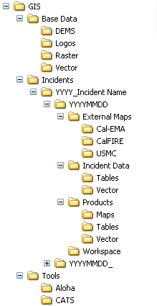

Figure 16-Example of a Directory Structure

(Source – NAPSG)

*NOTE – In addition to incident related maps and data, resources such as basemap data, GIS Map templates, layer files, scripts and other tools will be accessible on* **<<Folder location>>.**

### GIS File Naming Convention

**Example GIS File Naming Convention:**

Provided below is a recommended GIS file naming convention that can be applied. Be sure to consider your local regulations when defining this component of your SOP or SOG.

All data files (\*.shp, \*.xlsx, \*.dbf, \*.kml, etc.) must contain <<enter local regulations>>. Similarly, map document names (\*.pdf, \*.jpg, etc.) must contain <<enter local regulations>>.

**Example GIS File Naming Convention**

All data files (\*.shp, \*.xlsx, \*.dbf, etc.) must contain date/time, incident agency responsible for creating a map and subject matter qualifiers. Similarly, map document names (\*.pdf, \*.jpg, etc.) must contain date/time, incident name, subject matter information as well as size (e.g. 11X17, ANSI B, Custom32X66, etc.) and orientation (i.e. portrait vs. landscape) of the map.

* + Data file – yyyymmdd\_hhmm\_IncidentName\_Subjectmatter\_Agency
  + Map document - yyyymmdd\_hhmm\_IncidentName\_Subjectmatter\_Agency\_Size\_Orientation.\*\*\*
  + Example
    - MISS\_CanyonIncident2010\_06\_04\_2330\_ColorIndexMap\_FWRL.pdf – MODIS Color Index of Ocean Features and Circulation Patterns along with trajectories for June 4, 2010

For field collected data, also include a Source Code tag when naming the data file:

* GPS\_Name = Global Positioning System\_Collector’s Name
* FOBS = Field Observer
* SITL = Situation Unit Leader

For data/maps that were provided by Local, State or Federal Agency tag with Agency’s Acronym:

* CalFire (or relevant state agency)
* CDC
* Etc.

NOTE – When adding non-standard tags ALWAYS notify GIS staff of their presence and meaning. Also, it is the responsibility of each GIS responder to ALWAYS communicate the file naming convention that they are using to those with whom they are sharing the data.

Figure 17-Example of a GIS File Naming Convention

(Source – NAPSG)

## Communication

Good communication is a key component of any emergency response. Depending on the size of the tornado, any number of agencies/organizations at the local, state and Federal levels may be involved, and efficient communications (complete, concise and clear) are critical to an effective response. In all cases, the GIS professional should go through the EOC public information officer for communication to the public.

1. Within the EOC – The GIS Team Leader should communicate regularly with emergency management staff to determine their needs/priorities and ensure that they understand how GIS can assist them. In addition, where appropriate, the GIS Liaison should sit down informally with emergency management staff, work groups and task forces to learn about their issues, suggest to them how GIS can assist and relay that information to the GIS Team.
2. GIS coordination calls and data distribution lists – GIS coordination calls between adjacent communities, counties or the state should be made to minimize duplication of work and encourage sharing of assets. In major tornadoes, local GIS responders should work to closely coordinate with their state and Federal government counterparts. Being on GIS calls or getting feedback from them via a designated representative, can be essential to coordinating GIS activities as well as meeting various needs. To learn about these groups/calls if you are working with local government, it is suggested that you contact your state GIS Team Leader in the EOC or the State Coordinator/GIO. If you are working at the state government level, you should be communicating with your county/local government level as well as the Federal government (typically, through your regional FEMA Regional Geospatial Coordinators) when applicable.

Also, there are typically emergency management coordination calls that occur between groups that are working on the incident. It is important for a representative from the GIS group be involved in these calls to get a firsthand idea of their needs.

1. The Public – Subsequent to a tornadic event, the public will be looking for information. Press releases and news-based information will be handled through the Public Information Officer (PIO) that the Unified Command establishes. Typical information that GIS can assist in providing the PIO is the number of structures damaged or families displaced, evacuation zones, the location of shelters, road closures, etc. The GIS Team should also coordinate with the PIO to explore opportunities to communicate geographically relevant information to the public through the use of mobile-based applications, social media and web-based portals. These products and resources should be coordinated and approved through the incident’s Joint Information Center (JIC) and/or Public Information Officer. It is important to remember that the majority of the population now interacts with the Internet through their mobile device more often than through a computer. After a tornado, that may be the most effective means to provide them with appropriate information. Also, when delivering information for public consumption, keep mobile devices in mind when exporting images. Resolution and file size are critical, and in some cases, multiple files (mobile view and full view) may be preferred. Opening a 4MB png/jpg map may not be preferred for a mobile device.

Some communities such as New York City and San Diego have already developed applications for major incidents (“Ready NYC” and “Ready San Diego”) designed for mobile devices that provide tips, encourage citizens to make a plan, put together an emergency kit, and sign up for alerts on evacuations, locations of shelters, etc. This provides a quick and efficient way to keep the public informed through a device that they typically carry with them throughout the day. Other organizations such as the Red Cross have mobile applications ([http://www.redcross.org/prepare/mobile-apps](http://www.redcross.org/prepare/mobile-apps" \t "_blank)) that should be considered for information delivery as well.

1. Social Media – Social media can not only serve as a means to send valuable information out to the public, it can also provide the GIS Team with valuable insight into what is happening to citizens impacted by the tornado. If possible, GIS staff should monitor that to ensure that they have a broad idea of current situation, photographs and other descriptive information.

## Mapping Protocols

**Background*:*** It is recommended that map templates be designed with local base data and standard symbology (refer to Map Symbology Guidelines) be identified prior to an incident. Templates streamline the process of delivering maps out to the emergency management team and first responders, especially during the initial response period. It is common to change map templates and elements as the incident evolves, expands and contracts.

The use of the US National Grid (USNG) should also be incorporated into your agency’s SOG’s and policies where appropriate. Resources to support the implementation of USNG are available from the Federal Geographic Data Committee (FGDC) (<http://www.fgdc.gov/usng>) and from NAPSG (<http://www.napsgfoundation.org/wp-content/uploads/2014/01/Implementation-Guide-to-The-USNG.pdf>).

It is important to establish QA/QC procedures. Before a map is released from the GIS Unit/Branch, all map elements must be updated including author/contact person, date/time, scale bar, file location information, title, legend, and symbology. Special attention should be paid to time and date information. This information is critical when asked to reproduce a map or for after-action reporting, funding or for litigation purposes. All products should be archived as PDF’s (with date and time noted) to preserve their integrity.

Agencies should establish standard and optional map products for tornadoes. GIS professionals should meet with emergency managers to determine their needs, what standard products will be produced and what data layers, tools and models that will be required. It is recommended that mapping products be decided prior to tornado season. This allows GIS professionals to create templates, familiarize themselves with the data commonly used, and have input on various ways GIS can be used to assist emergency managers and first responders in the aftermath of a tornado.

It is important to recognize the potential that a mobile application may need to be made available to the public. When possible, determine what kind of information will be included in it pre-incident.

* **Purpose:** In order to promote clear communication and ease of use, all GIS staff should follow the guidelines listed below when creating map products in support of a tornado.

### User Defined Operating Picture

Many emergency managers and first responders utilize a User Defined Operating Picture (UDOP) for emergency response. A UDOP provides a single viewer that contains relevant GIS data and tools that multiple command centers or groups can utilize during an incident.

The information presented in the UDOP can be used on a computer, through a tablet or Smartphone application, or a web-based viewer. This allows emergency managers and first responders to be completely mobile and take their response efforts outside of the physical confines of the command center and creates an environment that all responders involved can utilize.

GIS technology has moved towards the use of a UDOP as the underlying infrastructure that data, tools and various applications are built on. It is built on a GIS database web server such as ArcServer, ArcGIS Online, or an open source equivalent. It has the capability to manage content and operations, display situational awareness, engage the public, gather data and deliver content. Its most powerful feature is the ability to make content available to many different target applications/technologies.

### Consumable Services

Consumable GIS services reside on a web server and are accessed over a network, allowing data, maps, tools and other GIS resources to be shared. This is known as a Service Oriented Architecture (SOA). One benefit of using consumable services is that updated data and maps are immediately available to everyone using the service as soon as the updates are made. Another benefit of using SOA is that one dataset can be consumed by many different users or web applications. This allows for data to be created once and utilized in multiple maps or applications. It is important to note that when implementing an SOA, the data archive still needs to be maintained. This must be designed into the system before an incident so processes are in place to perform data replication and archiving during the event.

* + GIS Services are available at: <<Fully-Qualified Server name/ArcGIS/Rest>>

### Map Templates

* Map Templates are available at: <<Folder location or hyperlink>>
  + Use the Templates available at this location to create all map products, whenever possible.

### Map Elements

**Example Required Map Elements:**

* Title – Includes incident name, map theme, geographic extent, date/time of the data or product
* Legend
* Scale bar
* Logos and data disclaimers
  + Logo and data disclaimer to recognize data sources
  + Logo and data disclaimer to recognize county group/department/division
* File Location– provide the full path name for the network location of the map document; e.g. C:\GIS\Incidents\yyyy\_IncidentName\YYYYMMDD\Products\yyyymmdd\_hhmm\_IncidentName\_Subjectmatter\_Agency\_Size\_Orientation.mxd
* North arrow
* Projection – Name of the projection, datum (including vertical datum), and units
* Data Sources – who, what, where, when, why and how (source codes - refer to page 21 of <http://www.nwcg.gov/pms/pubs/GSTOP7.pdf> NWCG SOP)
* “Time Sensitive Data” disclaimer stamp – for all maps that are time sensitive
* “DRAFT” stamp – if map is a draft

### Product Format Conventions

* + Share completed map products with ***<< Enter agency/section>>*** in ***<<Enter format>>*** format.
  + Export maps with 100 dpi resolution to keep file size down, unless a higher resolution is necessary to see detail (300 dpi is recommended for hard-copy print maps). This eases data sharing and load on networks.

### Map Symbology Guidelines

* + Symbology should be clear and understandable within the context of the visual presentation.
  + Symbols that are clear and understandable on an image background may not be appropriate on lighter cartographic backgrounds.
  + Symbology designed for static, paper maps may not be appropriate for electronic or interactive formats.
  + Reference the most widely used symbol set by your jurisdiction.
  + There is no nationally adopted incident-level standard symbology set. This is an evolving topic that DHS, FEMA, and NAPSG are currently working to address. Working with DHS and FEMA, NAPSG has developed a symbol set specifically for MACC’s, which is available through the NAPSG website at: <http://www.napsgfoundation.org/>.

**Example Map Distribution Guidelines:**

* GIS staff are not at liberty to distribute maps or GIS incident data to the media or public. Incident Command has the sole authority for approving the release of GIS products.
* Incident maps may be distributed to the Public if requested/instructed by ***<<Enter position>>*.**
* Any GIS products released to the public are considered public information and can be posted for distribution via the Internet. Always check to ensure that data released with these products are not restricted for distribution in any way.
  + The FGDC offers some suggested symbology that may or may not support the needs of your agency. For these resources visit - <http://www.fgdc.gov/HSWG/index.html>.

### Map Distribution Regulations

### QA/QC

* + Strive for excellence on the initial version. If a bad map or bad data are discovered, notify and update the <<enter GIS position>> immediately. The GIS group (and all individuals referring to the map/data) will be notified via <<Identify channels for communicating QC related issues>>, identify exactly what the flaw is, work to correct the map and redistribute it immediately.
  + Remove incorrect data or maps from locations such as published web applications as soon as possible, but do not permanently delete the bad information from the disk drive. Instead, add a tag to the file name indicating that it is bad data and should not be used. A record of any bad data that was released may need to be accessed at some point during or after the event.
  + Perfect is a goal. Complete is more realistic. It is most important to get “the message” across to the viewer as clearly and efficiently as possible.

### Archiving

* + Knowing what occurred and when it happened during an event can be invaluable both during and after that event. It is strongly recommended that a PDF of all map products with a date and time noted be created and archived after each product is distributed.

### Standard Map Product Definitions

The standard map product definitions section outlines the objectives, target audience, data content and cartographic requirements for those map products. These map products communicate incident specific details as well as general environment and infrastructure information to support emergency management operations.

<< Enter standard map product definitions>>

### Optional Map Product Definitions

The optional map product definitions section outlines the product objectives, the target audience, data content and cartographic requirements for those map products that are *optional* for all state or Regional Multi-Agency Incidents. These map products provide supplementary and specialized information for use during the response and recovery phases of the incident. Other ad hoc map products may also be requested to meet incident specific needs.

<< Enter optional map product definitions>>

## Data Protocols

**Background:** It is recommended that data formats, data and map transfer protocols, and back-up policies be standardized prior to an incident. Things to consider include the native data and file formats that emergency responders and other GIS responders will be accessing. For example, if a .dbf table is distributed out to emergency management officials and they use Microsoft Excel to open the file, they will receive a warning message. Most responders will not go beyond the warning message to access the file. Another example is, if a .pdf or .kml file is distributed to field personnel and they do not have Adobe Acrobat Reader or Google Earth on their mobile device, the field personnel will not be able to open the file. Other options include ArcGIS Online or an open source equivalent.

It is recommended that consideration be given to storing all data and information in a cloud service as well as having it backed-up on local drives (and/or thumb drives within the EOC). This will normally prevent data loss due to network connectivity issues and ensure that it is being backed-up and stored properly. Local storage should be on a scheduled backup to ensure data/information integrity regardless of network/Internet connectivity issues.

The Briefing Cycles section is intended to give GIS responders direction for responsibilities and a timeframe for which products may need to be ready.

The Damage Assessment section is intended to give direction on how damage assessment data can be collected.

***Purpose*:**  This chapter discusses data format conventions, data backup and data sharing policies. One key to a successful GIS response is data preparation that promotes data and application interoperability.

**Data Format Conventions:**

GIS staff should adhere to the following Data Format Conventions. Examples provided here serve only as examples and do not set standards for the use of any particular software.

### Data Format Conventions

**Example – Data Format Conventions**

* Acceptable Data Formats include - <<Example: .xlsx, .dbf, .shp, File Geodatabase, KML.
* Post tables for GIS staff as .dbf for quick import into GIS software.
* When working with Excel spreadsheets remember that cell values linked to calculations will not be translated between .xlsx and .dbf. If there are values of consequence that are linked to a calculation, create a new field for the data values and perform a paste special (Values only) before converting to .dbf. Make sure that there are no spaces in the header row and worksheet tabs.
* Tables posted for consumption or use outside of GIS should be in an MS Excel (.xlsx) format to avoid software compatibility issues/warnings when opening the file.
* Acceptable Map [Output] Formats include - <<Example: .jpg, .pdf, .mxd
* When exporting to .jpg or .pdf use a resolution of 100 dpi (for printing hard copies 300 dpi is the recommended resolution) unless higher resolution is necessary to see detail. This reduces file sizes to accommodate file sharing and network limitations.

Keep your audience in mind. When creating products shared to mobile devices (i.e. through PIO), reducing the file size and reducing the bandwidth required to download the information is often more critical than increased resolution

* + Use the Relative Paths Option when sharing .mxd’s with others - Select the Document Properties option from the File Menu, followed by the Data Sources button in the “Map Title” Properties dialog. Then select “Store relative path names to data sources” and “Make relative paths the default for new map documents I create.”

NOTE – When posting zip files, use the same naming convention as the associated data files (refer to above naming conventions).

Figure 18-Example of Data Format Conventions

(Source – NAPSG)

### Briefing Cycles

During an emergency event, the <<Emergency Operation Center (or IC/DOC/MOC/etc)>> operates on a <<enter briefing cycle times, ex: 12 hour>> briefing cycle. Often <Enter briefing times>>, EOC Officials and/or Elected Officials and/or staff brief the media/public. These briefings provide information as to the extent of the area and population affected as well as actions enlisted by the <<jurisdiction or entity>> and other agencies to show the incident progression (if applicable) and reconcile the damage.

### Data Backup Policy

To avoid duplication of effort and loss of work products GIS staff are to adhere to the following practices <<Enter data backup policy>>

**Example Data Backup Policy**

* Perform and save all work in the workspace directory under the incident (or on your C: Drive if the network is unavailable or sluggish).
* Create backup copies of the files you are working on, on a regular basis.
  + Use a specific time interval. It is recommended this be done every 2-4 hours.
* Save/Backup work to USB memory sticks or to portable, external hard drives and the cloud (or on State servers, etc.).
  + Tip: Purchase a portable, external hard drive with backup software.
  + IMPORTANT – *Legal action* is often associated with post disaster mitigation, relief, and funding. Saving all your work and keeping a time log or journal of events, people, and requests made is highly suggested.
* When a product is complete, create a PDF of it with the date and time noted and save the file to an area designated as an archive.

Figure 19-Example of a Data Backup Policy

(Source – NAPSG)

### Information Availability

It is recommended that the GIS Team work with the emergency managers and first responders to establish a timeline for how long the data will be available during and after an event, what the process will be for requesting/obtaining the data, and what data will be available versus what data will need to be kept confidential. Communication about the post-event data will ensure that data distribution is done properly. It is important to note that local, state, and federal open records/freedom of information/right-to-know laws may have a bearing on the availability of information developed during or subsequent to an event.

## Data Acquisition and Dissemination

**Background:**  This section is intended to familiarize GIS Responders with the types of data that may be requested of them, data they may need to acquire, data they may need to create, and how that data is transferred. This section also provides GIS responders with federal GIS products and programs available to them. GIS Responders may want to refer to and become familiar with the Homeland Security GeoCONOPS. The Homeland Security GeoCONOPS lists various datasets and essential elements of information required to support federal GIS activities.

The Public Data Sharing/Exchange Policy section establishes the rules for data sharing and a policy for release of data to the news media and public. It is important to note that GIS responders are not allowed to release incident information to anyone outside the incident without following the policies identified within the jurisdiction. It is recommended that data and product sharing policies for adjacent communities and state agencies be established prior to tornado season to allow GIS efforts to be fully coordinated between each other and to reduce redundancies.

The Recommended Datasets section and Appendix 7 provide examples of datasets that GIS responders may need prior to tornado season as well as after a tornado strikes. GIS responders may also want to refer to and become familiar with the Homeland Security GeoCONOPS. Section 2.2.2 of the Homeland Security GeoCONOPS lists essential elements of information and relevant datasets used to support federal GIS activities. Each of these sources can provide a starting place to develop a GIS data list for the MACC. A list will aide individuals or entities that are not familiar with the local data if they are asked to provide GIS assistance. It is also a good idea to have this data available on an emergency DVD/CD, memory stick, or hard drive that can be shared with other responding agencies (such as the Urban Search and Rescue Teams) or to easily reload data in case of hardware failure. Lastly, it is strongly recommended that the data be backed up in the cloud to provide off site storage and access in case a significant event occurs.

Data connection information is important to include in case automatic data connections fail. Data connection protocols are not easily remembered when hurried or tired.

* **Purpose:** This chapter provides GIS staff with an understanding of the media briefing cycles, incident data, and damage assessment protocols.

### Data Management Plan

A Data Management Plan should address the following:

* Determination of what data is needed before and after a tornado.
* Determination of what data is available for use versus what data needs to be acquired/produced.
* Determination of how data will be acquired and by whom (in particular, after a tornado strikes).
* A plan for training staff to quickly and accurately acquire locational data in the field after the tornado strikes.
* Sharing protocols (including standards), data delivery schedules, data expectations, data formats, data collection formats/methodologies, information flow, roles of staff, methods (including how and who performs edits on data and version control methodologies) and systems used, locations of data and services, and documentation/archiving.
* The need for a database manager and database administrator to properly manage the GIS data.

A Data Management Plan, whether for a simple or complex incident, should be drafted and reviewed by all data providers to ensure that standards are followed. Having a plan in place prior to of an incident is essential so that initial data management is done properly, and the GIS staff are operating effectively and not having to expand efforts correcting QA/QC problems or data flow issues from the start of the response.

### Obtaining Event Data

Whenever possible, it is recommended that protocols be established for importing and displaying damage assessment data from mobile devices in the field. However, it is also recommended that agencies establish protocols for collecting data and creating maps when technology is not available (i.e., no Internet connection, no electricity, inadequate mobile devices, etc.). If field collection devices are not available, having a large-scale plotter to print paper maps (refer to the section on Map Books following) will assist the staff going out in the field.

Ideally, a mobile system will be available. This allows data updates to be pushed directly to the systems at the ICP for immediate consumption. If a designed technology is not available, then consider other options that allow field collection. Examples include: taking geo-referenced photographs with a smart phone that can be uploaded later, phone calls where geo-tagged data are called into the ICP, or paper-based forms that can be used in the field when no technology is available.

Also, it is important to establish protocols for verifying data (i.e. damage assessment, debris, etc.) that is collected in the field. This is particularly important when those data are collected using paper forms or other non-technology-based methods, such as pre-printed, grid based Mapbooks with a data collection instruction page and form. Establish these protocols early in the process to ensure consistent data is being collected for the duration of the incident. This especially important as contractors may collect these data and they are often not as well trained as government field staff. At a minimum, a standardized data collection form should be used and should include a minimal amount of metadata.

### Essential Elements of Information

The recommended GIS data list that follows and those listed in Appendix 7 detail GIS datasets that are important for supporting the GIS functions outlined in these standards. Section 2.2.2 of the Homeland Security GeoCONOPS provides additional detail on Essential Elements of Information (EEI) supporting federal emergency management operations. The relevant datasets are listed in Appendix B of the Homeland Security GeoCONOPS. These EEI’s may vary by specific incident type, but generally include information such as disaster boundaries, socioeconomic impacts, critical infrastructure, etc.

There are many ways for local jurisdictions to obtain base and incident specific GIS data. It is recommended that MACC’s leverage existing data warehouses from local jurisdictions and state agencies to locate needed data. Contact your state’s GIS Coordinator or Geographic Information Council to find out what state or regional data warehouses or portals are available. For a listing of State GIS Coordinators visit: <http://www.nsgic.org/state-representatives>. Other sources include the National States Geographic Information Council’s GIS Inventory (<http://www.nsgic.org/gis-inventory>) and a list of state GIS clearinghouse sites (<http://www.nsgic.org/state-information>); and the Federal Government’s (<http://www.data.gov/open-gov/>).



**Example Recommended Datasets:** The recommended Datasets List details GIS datasets that are recommended in support of the mapping functions outlined in these standards. The Homeland Security GeoCONOPS provides additional detail on EEI’s supporting federal emergency management operations. Trusted datasets are listed in Appendix B of the Homeland Security GeoCONOPS. An example from the State of Missouri can be found in Appendix 7.

**Example Recommended Datasets (Gathered Prior to the Event)**

**Imagery**

* Purpose: Identify current conditions
* Aerial imagery with date
* Oblique aerial imagery (i.e. similar to Pictometry) (optional)

**Elevation**

* Purpose: Identify current conditions and areas prone to flooding
* Digital Elevation Model
* Topography
* LiDAR (optional)

**Land Ownership/Administrative**

* Purpose: Identify ownership and appropriate jurisdictions
* Address points/ranges
* Parcel boundaries w/CAMA data
* Municipal and administrative boundaries
* Businesses located on property
* Landmarks

**Hydrography**

* Purpose: Identify pre-storm conditions
* Hydrography
* Levee locations
* Watersheds

**Utilities**

* Purpose: Identify infrastructure that could be damaged. Identify infrastructure that could be hazardous. Provide guidance for access by first responders.
* Utility pipelines
* Power lines (optional)
* Power plants (including nuclear power plants)

**Recommended Datasets (Gathered Prior to the Event) Continued:**

**Transportation**

* Purpose: Identify access routes to the incident, evacuation routes, and other related transportation reference points. Support routing of public vehicles (evacuation/ avoidance).
* Roads
* Evacuation routes
* Bridges and tunnels
* Railway lines and stations
* Bus, subway and light rail lines and stations
* Ferry lines and terminals
* Airports
* Helicopter landing zones
* Transportation resources - buses, school buses (with wheelchair access), ambulances

**Population**

* Purpose: Identify impacted and at-risk populations.
* Population data/U.S. Census
* Nighttime population vs. daytime population
* Seasonal population (where applicable)
* Businesses
* At-need population (schools, day care, nursing homes, assisted care facilities, universities, hospitals/clinics, urgent care, mental health and correctional facilities, etc.)

**Public Safety Data**

* Purpose: Identify public safety and incident command facilities
* Fire stations
* Police stations
* EMS
* EOC’s (local, State, Federal)
* Public Safety Answering Points (PSAPs)/911 Call Centers
* Shelters (shelters, shelters allowing pets, animal shelters)
* Staging areas
* Incident command post
* Evacuation zones

**Search and Rescue**

* Purpose: Define and train with a grid that can scale for local, regional, state and Federal search and rescue teams.
* United States National Grid (USNG)
* Data packaged on hard drive or other portable device to provide to Search and Rescue Teams from out of the area.

**Recommended Datasets (Gathered Prior to the Event) Continued:**

**Critical Infrastructure**

* Purpose: Identify critical infrastructure not otherwise covered in other categories
* Local/State identified critical infrastructure
* DHS Homeland Security Infrastructure Program (HSIP) data is available for use as HSIP Freedom and HSIP Gold. It provides data in many of the categories listed above. Access to HSIP Gold data requires a Homeland Security Information Network (HSIN) account. For more information, go to: <https://gii.dhs.gov/hifld/>.

**Other Facilities** (Refer to detailed data listing provided by Debbie Briedwell MO SEMA in Appendix 7)

* Purpose: Identify facilities not otherwise covered in other categories

**Chemical and Other Environmentally Related Facilities**

* Purpose: Identify environmentally related facilities
* Chemical facilities & extremely hazardous and hazardous sites (SARAH Title 3 sites)
* Sewage treatment plants
* Public wells
* Public reservoirs
* Pumping stations
* Oil and gas farms
* Sanitary Sewers
* Water Treatment Plants
* Potable water mains
* Storm water facilities (catch basins, storm sewers, outfalls)

**Weather**

* Purpose: Identify weather related data prior to an event
  + Obtain data on location of the greatest tornado risk, time frame, etc.via NWS weather forecast offices or regional operations centers, the Storm Prediction Center, etc.

**Recreation**

* Purpose: Identify recreational facilities as well as places with potential users
* Public beaches
* Parks & campsites
* Ball fields
* Stadiums and other large recreational facilities

Figure 20-Example of Datasets Recommended Prior to a Tornado

(Source – NAPSG)

**Recommended Post Tornado Datasets (Gathered after the tornado)**

**Weather**

* Purpose: Identify event-related or future conditions that may influence initial response efforts (refer to the next section for additional details)
* NOAA/NWS forecasts
* Atmospheric conditions (temperatures, rainfall impacts, wind speeds, etc.)

**Imagery\*** (Refer to section on Compiled Imagery in proceeding text)

* Purpose: Identify event related conditions that may influence response
* Post storm aerial imagery
* Civil Air Patrol photographs
* Satellite imagery
* Oblique aerial imagery (i.e. Pictometry or similar)

**Incident Specific Data**

* Purpose: Identify response requests and efforts made
* Requests for assistance
* Rescues
* Evacuations
* Fires
* Deaths
* Activated evacuation zones
* Activated staging areas
* Debris sites
* Communications trailers
* Volunteer reception centers
* Shelter, food, medical and pharmacy locations
* Temporary morgue(s)
* Supplies (i.e. emergency generators, medical supplies, food, water, etc.)
  + Shelter supply needs (food, water, fuel, clothing)
* Closures of critical infrastructure (schools, day care, nursing homes, assisted care facilities, universities, hospitals/clinics, urgent care, mental health and correctional facilities, etc.)

**Utilities**

* Purpose: Identify damaged electrical and phone infrastructure.
* Power outages

**Communications**

* Purpose: Identify potential communication outages due to the incident.
* Cell towers
* Radio communication
* Main Internet hubs/lines
* Telephone (land line) facilities and lines

**Recommended Post Tornado Datasets (Gathered after the tornado):**

**Transportation**

* Purpose: Identify access routes to the incident, evacuation routes, and other related transportation reference points. Support routing of public vehicles (evacuation/ avoidance).
* Road closures
* Airport closures
* Rail and subway closures or stoppages
* Bridge closures (including moveable bridges)
* Active evacuation routes

Figure 21-Example of Datasets to be Acquired After a Tornadic Event

(Source – NAPSG)

### Determining the Tornado’s Path

Those interviewed for this document that had previously responded to a tornado, stated that the first important step for the GIS Team is to identify the damage path. Furthermore, it was a clear from the discussions that producing even a crude representation of the tornado’s path as quickly as possible, then refining it as more data became available, was the preferred methodology. There are a number of approaches that can be considered in order to capture the data. Whether the GIS Team uses radar, imagery, social media reports, boots on the ground or a combination of those methodologies, the goal is come up with an initial assessment ***quickly*** to provide the emergency managers and first responders with a tool to visualize the extent of the situation.

* National Weather Service (NWS) Data – The NWS) has 116 local Weather Forecast Offices and four Regional Operations Centers across the contiguous U.S. As previously noted in the Standing Orders, the GIS Team leader needs to initially establish a relationship with the local or regional NWS office(s) to determine the best data and models available. Among the information that it provides initially, are radar images and other data of the storm. The Commonwealth of Virginia has successfully used weather radar data from the NWS (<http://www.spc.noaa.gov/climo/reports/>) and Iowa State University (<http://mesonet.agron.iastate.edu/vtec>) to provide an approximate tornado path, which has proven to deliver some of the most immediate results. (Refer to Figure 25)

It should be noted that the NWS continues to build out its preliminary tornado track capabilities immediately following a high-impact event, where a NWS meteorologist uses all available observational and remote sensing data at their disposal (radar, satellite, weather spotters, etc.) to determine a reasonable worst case damage path. It is incumbent on the GIS Team leader look for new techniques or technologies being introduced by the NWS on a regular basis.

The NWS also conducts a thorough storm damage survey typically within 24-48 hours of a significant event, where trained NWS meteorologists on the ground verify and refine the tornado track, take geo-tagged photographs, report known damages, and assign a preliminary Enhanced Fujita Rating. This data is readily available on the NWS Damage Assessment Toolkit: <http://54.243.139.84/StormDamage/DamageViewer>. This includes having its trained meteorologists on the ground to verify the path and the wind speeds of the storm. As dual-polarization radar have now been deployed across the country, its capabilities have steadily improved.

* Imagery – Ideally, the path would be captured in a geo-rectified image and provided to the GIS Team in the EOC within the first hour following the event. However, that’s just not a reality for the vast majority of tornadoes at the local government level. To begin with, most storms occur in the late afternoon or early evening when daylight is waning. In addition, there may be a threat for additional inclement weather that may prohibit aircraft from flying. Furthermore, most local governments don’t have the resources or the funds to contract for aircraft hours. The Civil Air Patrol or state or local police may be able to offer assistance, but they will be subject to the same weather restrictions as others. In some cases, local television stations or newspapers may capture the event. While not ideal, this can provide assistance in developing an initial location of the tornado’s path. In the future, the use of drones may also be a consideration to aid in these efforts, but there is much to be determined regarding their use.
* GPS – At present, the use of GPS to quickly identify the perimeters of the storm’s path is the most widely accepted methodology by local governments. To be most effective, this requires the use of both GPS units and trained staff. Using first responders is not the preferred method because of conflicting priorities. (The priority of first responders is to save lives. The priority of the staff using GPS units is to gather data efficiently and provide data to the GIS Team as soon as possible.) Depending on the size of the community impacted and volunteers needed as first responders, this means that GIS professionals may be tasked to perform this work. It is preferred that other staff be designated and appropriately trained prior to the typical tornado season. However, the key is to have a pre-established methodology and trained staff identified and well trained to obtain this data in a timely manner (preferably, before dark) far in advance.
* Map Books – In our discussions with local GIS professionals that had provided support for emergency responders after a tornado, we were constantly reminded that, in times of crisis, most often, the simpler tools work best! Map Books were mentioned numerous times. These were seen as invaluable to non-technical first responders from the area, and even more valuable to those coming to a community from outside of the area who simply needed information on “where to go.” Those who successfully used them indicated that most responders simply were most comfortable and most effective annotating on paper or laminated map with a writing utensil.

The key was preparation and here are some suggestions:

* + Develop them long before tornado season
  + Use the U.S. National Grid coordinates in addition to Longitude and Latitude or State Plane coordinates
  + Use standardized symbols
  + When working at the local government level, coordinate with neighboring communities or regions to ensure that the maps are consistent across boundaries. (Remember, tornadoes don’t recognize political boundaries)
  + Back up your map books on hard drives, to the cloud (if available), or at the state EOC level
  + Once the approximate location of the tornado’s damage path has been determined, provide field staff with larger scale maps of the impacted areas.
  + Have a system developed to recover the annotated maps each shift/day (if possible) to allow event related data to be updated and provide updated maps to field as soon as possible
* Social Media – The use of social media by the general public has grown exponentially over the last few years. If this source of information is mined properly, it can provide a quick snapshot into the potential impact of the storm. If the GIS Team has the resources to review this data, it can prove valuable. (Refer to the section on Crowd Sourced Data that follows.)

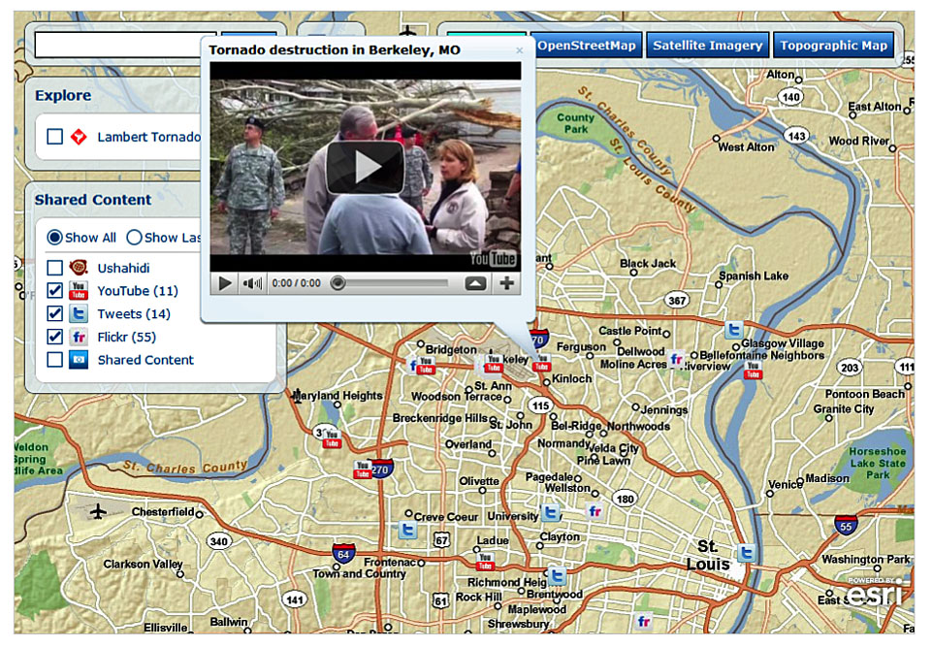

Figure 22-Social Media Feeds Displayed in an Interactive Map

Provided by the Esri Disaster Program Following a Tornado in St. Louis, MO

(Source – Missouri Emergency Management Agency)

**Commonwealth of Virginia’s Model for Quickly Determining the “General” Location of a Tornado**

**Methodology**

* Determine the date/time and general location of the tornado
* Identify closest radar site
* View radar data during event period
* Identify points of interest (Refer to graphic below)
* Export to GIS

**Determine Time/Location**

* Early warning NOAA storm reports: <http://www.spc.noaa.gov/climo/reports/>
* Iowa State University Weather Warning Archive: <http://mesonet.agron.iastate.edu/vtec>

**NCDC Weather/Climate Toolkit**

* Desktop application that can view radar data
* View radar sites
* Overlay base maps
* Annotate and create user-defined points
* Export to shapefile, cvs, etc.
* Export animated radar data: <http://www.ncdc.noaa.gov/oa/wct/install.php>

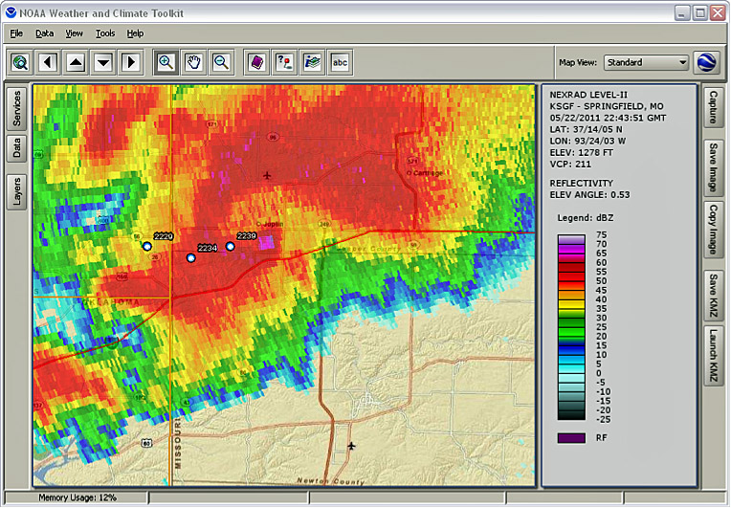

Add a marker at the center of the debris ball

**Commonwealth of Virginia’s Model for Quickly Determining the “General” Location**

**of a Tornado**

**Display**

* Create “possible tornado path” by connecting the “marker” points
* Buffer the “possible tornado path” by ¼, ½ and ¾ miles on each side to estimate a corridor
* REMEMBER: This buffer area does NOT indicate where damage actually occurred. It shows where to look for possible impacts!

*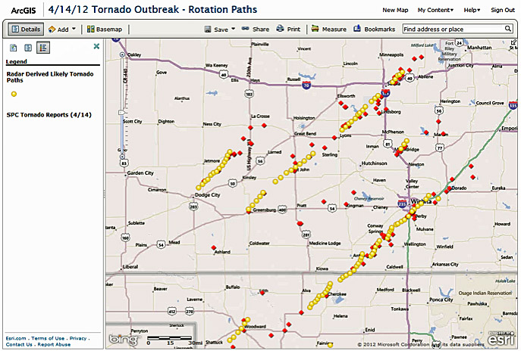*

Figure 23-Model for Quickly Determining the General Location of a Tornado [[7]](#footnote-8)

(Source – Virginia Department of Emergency Management)

### Compiled Imagery

During disasters, the number of imagery sources is sometimes overwhelming. In addition to the State website, the FEMA GeoPlatform (<http://fema.maps.arcgis.com/home/>) and the USGS Hazards Data Distribution System (HDDS) (<http://hdds.usgs.gov/hdds2/>) may be good resources to consider. It is suggested to coordinate with the FEMA Geospatial Regional Coordinator to find out about other opportunities that may arise.

### Crowd Sourced Data

During major disasters, citizens provide unique information on impacts in their community. Whether it’s a 140-character description on Twitter or a photograph on Facebook or other social media site, this information can provide insight into events unfolding throughout the area. Leveraging crowd-sourced data can provide valuable insight for the EOC. Web sites such as Tomnod (<http://www.tomnod.com>) use algorithms/statistics that are able to exclude data outliers and provide much more useful information. The Department of Homeland Security provides applications and websites as well: <http://www.dhs.gov/blog/2013/08/06/crowdsourcing-disasters-and-social-engagement-multiplied>.

Additionally, many agencies are utilizing tools such as ArcGIS Online and Google’s Crisis Mapper to enable crowd sourcing of geographic reports. As different organizations respond to the event and carry out their mission-driven responsibilities, many share information using platforms such as ArcGIS Online. This provides the opportunity to access authoritative crowd sourcing, which is data collected by authoritative sources and provided over the Internet through web services. By exposing their operational data, organizations participating in a response can augment the overall User Defined operational picture with their authoritative data.

### Damage Assessment

As outlined in Section 5.2.3 of the Homeland Security GeoCONOPS, *“*Damage assessments provide a vital flow of information to the response community. The data collected and compiled through Damage Assessment activities defines the locations and levels of magnitude of event-related impacts. The combination of imagery resources, models, and ground truth data provide rapid estimates and quantitative field observations to assist in making critical decisions in the early phases of the disaster operation.”

The following table includes an example of the FEMA wind damage classifications. More information on damage assessment is available at: [http://www.vaemergency.gov/em-community/recovery/damage-assessment](http://www.vaemergency.gov/em-community/recovery/damage-assessment" \t "_blank) and <http://www.vaemergency.gov/sites/default/files/PA_guide_template_color021507.pdf>. These classifications are recommended for use by all agencies. Use of these classifications as well as the use of a common grid (such as the USNG) will streamline the collection and consolidation of local damage assessment efforts. It will also facilitate the transfer of data to state and federal agencies. To be most effective, GIS professionals who have used this approach stress that forms must be created for field staff to define their evaluations. While this might be best done with digital forms on mobile devices, paper forms can work almost as effectively and need to be created as a back- up system regardless.



Figure 24-Example of a FEMA Wind Damage Classification

(Source – FEMA)

### Calculating the Cost of the Storm Damage

In the aftermath of a tornado, one of the areas that GIS can really shine is in calculating the cost of the storm damage. This can be done by combining the information provided by the field damage assessment with the local parcel database to provide an authoritative damage cost assessment of the storm. Using GIS to perform this task can eliminate significant work for the emergency management staff, and allow the community to apply for recovery funds using an organized methodology. The GIS professional in the EOC should become familiar with FEMA’s damage assessment process: <https://www.fema.gov/public-assistance-preliminary-damage-assessment> and their Local Damage Assessment Toolkit: <http://emilms.fema.gov/IS559/lesson6/Toolkit.pdf>, and, work with the appropriate staff within the EOC to develop forms that can be used in the field to evaluate the damage in an organized and defensible manner. The GIS professional can take the percentage of damage and tie it into the value of the property to provide a defensible cost of the storm. In the end, not only does it provide a valuable product quickly and efficiently, it can also help to educate the emergency managers in the EOC on the value of GIS.

### Calculating Debris Removal Quantities and Costs

Another area where GIS has been effective in the aftermath of a tornado is to calculate the cost of debris removal. Depending on the type of debris, a value can be placed on the overall project, and can be used to request recovery funds. It can also be used to define the resources required if the community contracts for the debris removal. FEMA has a number of documents to provide guidance in this area. Some additional tips that might prove useful can be found at: <http://construction.about.com/od/Commercial-Remodeling/a/Debris-Removal-Tips.htm>.

### US National Grid

The use of a standardized grid, such as the USNG should also be incorporated into your agency’s SOG’s and policies. The USNG is a system of point grid references commonly used in the U.S. It provides a nationally consistent language in a user-friendly format. Utilization of the USNG will aid in interoperability between local, state, and federal agencies should the need arise. Resources to support the implementation of USNG are available from the USNG Implementation Center (<http://www.deltastate.edu/college-of-arts-and-sciences/center-for-interdisciplinary-geospatial-information-technologies/>) and from the FGDC (<http://www.fgdc.gov/usng>). For more information on USNG see: <http://napsgfoundation.org/wp-content/uploads/2014/01/Implementation-Guide-to-The-USNG.pdf>.

### International, National & Federal GIS Products and Programs

There are many Federal GIS data and tools resources available to state and local agencies. The following list is not inclusive of all programs, but will provide a broad overview of products available to local agencies.

#### Data.gov

Data.gov is a U.S. government website launched in late May 2009 to increase public access to high value, machine readable datasets generated by the Executive Branch of the Federal Government.

To learn more about the accessing GIS data from it, go to: <https://www.data.gov/geospatial/>.

#### NSGIC GIS Inventory

#### The GIS Inventory is managed by the National States Geographic Information Council (NSGIC) as a tool for states and their partners. Its primary purpose is to track data availability and the status of GIS implementation in state and local governments to aid the planning and building of Spatial Data Infrastructures. It can be used by public safety agencies, mutual aid groups, EOC’s, and MACC’s as a “yellow pages” directory for GIS information and also as a tool to share links to data and web mapping services to support public safety at the local and state levels. Refer to: <http://gisinventory.net/>.

#### NSGIC Emergency Contacts Listing

#### NSGIC provides a listing of emergency GIS contacts for every State as well as Puerto Rico, the District of Columbia and U.S. Virgin Islands. The listing also provides contacts at DHS, FEMA, USGS, EPA and other Federal agencies along with State Adjutant Generals. Its primary purpose is to provide 7x24x365 contact information for GIS professionals who could be involved in an incident. This information is not for public distribution, but is available for government use and can be obtained through the State Geographic Information Officer or GIS Coordinator at: <http://www.nsgic.org/state-representatives>.

#### DHS Geospatial Information Infrastructure (GII)/HSIN

Other data and data classified as “For Official Use Only” and “Sensitive But Unclassified” is available through the DHS Geospatial Information Infrastructure (GII) tools. Using the Homeland Security Information Network (HSIN) for identification management, the GII is able to provide a national secure and trusted web-based portal for GIS information sharing and collaboration between federal, state, local, tribal, and territorial governments, the private sector, and international partners engaged in the homeland security mission. Access to those sources is limited to individuals who have been credentialed by DHS. Those wishing to go through that process can find out more by going to: <https://gii.dhs.gov/hifld/>.

More information on the DHS OneView and other GII resources can be found in Appendix E of the Homeland Security GeoCONOPS.

#### HSIP Freedom and Gold

The Homeland Security Infrastructure Protection (HSIP) dataset is a compilation of over 450 GIS datasets, characterizing domestic infrastructure and base map features, which have been assembled from a variety of Federal agencies and commercial sources. HSIP Freedom data is a subset of the HSIP Gold datasets developed and previously compiled through a partnership amongst National Geospatial-Intelligence Agency (NGA), DHS GMO, Department of Interior (DOI), and Office of the Secretary of Defense for Homeland Defense (OSD HD) since 2006. HSIP Freedom can be distributed among state and local government agencies, and is being made available through the DHS Geospatial Information Infrastructure (GII) enterprise platform. HSIP Gold can be requested the DHS GII.

#### HIFLD

The Homeland Infrastructure Foundation-Level Data (HIFLD) working group was established in 2002 to address desired improvements in collection, processing, sharing, and protection of homeland infrastructure GIS information across multiple levels of government and to develop a common foundation of homeland infrastructure data to be used for visualization and analysis on all classification domains. In 2015 HIFLD became a Subcommittee of the Federal Geographic Data Committee. For more information on federal GIS products and programs visit: <https://gii.dhs.gov/hifld/>.

#### The International Charter

The International Charter is a collaboration effort among space agencies to provide a mechanism for rapid tasking of satellites for immediate response to emergencies. Free satellite-based information is provided to national disaster management authorities and humanitarian organizations to support immediate response to major natural or man-made disasters.

The Charter has been activated for more than 450 disasters in over 120 countries since its inception in 2000 (as of the date of this publication). The Charter gives access to a constellation of satellites equipped with radar and optical sensors. Information on the Charter can be obtained from going to: <http://www.disasterscharter.org/web/charter/home>. For more information regarding the Charter, including requesting an activation of the Charter in response to a disaster, please contact Brenda Jones: [bkjones@usgs.gov](mailto:bkjones@usgs.gov) or Ryan Lamb: [lamb@usgs.gov](mailto:lamb@usgs.gov). Please note that local governments should coordinate their needs through their State GIS Coordinator/Geographic Information Officer (GIO) (<http://www.nsgic.org/state-representatives>).

#### Virtual USA

Virtual USA was a collaborative effort developed by DHS. It aims to connect various disparate state emergency management GIS data into one User Defined operational picture by utilizing current information-sharing platforms to permit new and existing technologies to seamlessly exchange information with one another. Currently, Virtual USA is transitioning to the National Information Sharing Consortium (NISC). For more information see: <http://www.nisconsortium.org/nisc-activities/virtual-usa-2/>

#### The National Map

The National Map makes accessible the base geographic data layers found on USGS topographic maps. They are useful in planning and responding to disasters. The National Map provides access and down load capabilities for the critical GIS information needed to respond effectively to disasters of all types. For more information on The National Map, go to: <http://nationalmap.gov/>.

### State/Local GIS Products and Programs

Included in this document are examples of state and local GIS products and programs that are used during an emergency event. We encourage you to customize this list, and add any products or programs relevant to individual agencies. Examples can be found in Appendix 4.

### Data Dissemination

Section 2.6.2 of the Homeland Security GeoCONOPS gives an overview of recommended ways to share data:

*Vector data products are fairly compact in individual file size, facilitating data sharing through web services, e-mail, and web postings. With agile delivery options, emergency managers have access to these data products in a timely manner to assist in their decision-making. Larger data files such as imagery or national datasets are more difficult to manage. Frequently these data types are shared through the physical transfer of external hard drives and other portable media or provided virtually through the cloud.*

For dynamic data exchanges, DHS supports the National Information Exchange Model (NIEM) and the Open Geospatial Consortium (OGC) standards to facilitate data dissemination and information exchange. NIEM represents a collaborative partnership of agencies and organizations across all levels of government (federal, state, tribal, and local) and with private industry. The purpose of NIEM is to efficiently share critical information at key decision points throughout the justice, public safety, emergency and disaster management, intelligence, and homeland security enterprise. NIEM is designed to develop, disseminate, and support enterprise-wide information exchange standards and processes that will enable jurisdictions to automate information sharing. NIEM includes twelve domains. NIEM emergency management domain data elements and attributes were derived from existing messaging standards promulgated by the EDXL initiative, including the Common Alert Protocol (CAP v1.1), Distribution Element (DE), and Hospital Availability Exchange (HAVE), EDXL functions as a stand-alone suite of messaging standards. NIEM leverages EDXL concepts and methods. OGC is an international industry consortium of government agencies and organizations, universities, and the private sector that develops publicly available interface standards that are geo-enabled and interoperable.

A common information storage system must be identified to maintain transparency and access to response information as well as for archival purposes. This system should not be based on proprietary software (unless information sharing agreements are in place) and should have the ability to store high volumes of multiple types of information (databases, GIS files, documents, maps, photos, etc.). The system must be accessible by all responders and must account for certain software and hardware restrictions that both private industry and government organizations require. For GIS files, the system must offer the ability to quickly refer back to the previous day’s data view. If ESRI ArcGIS server, ArcGIS Online or Google Earth environments are used, they must allow for easy access to old data views and the “archiving” process must not include overwriting of old datasets. If a Secure FTP (SFTP) site is used, it must be backed up daily, have restricted access, and be closely managed. If a cloud platform is used, local backups are suggested in the event of power or Internet service outages.

In the past events, a SFTP has been stood up for large incidents. We recommend an SFTP type structure be used as a “working” information environment. An SFTP allows personnel distributed across the country to access and upload documents. Other more appropriate archival databases could be utilized as well.

Applicable local, state, and federal open records/freedom of information/right to know laws may have bearing on the availability of information developed during or subsequent to an event.

### Data Dissemination Protocols

Data dissemination is a vital part of incident response. This process needs to be as simple, efficient, secure, and accessible as possible. Automation of data updates and methods for seamlessly providing data, that does not require human intervention, will maximize interoperability and effectiveness. A detailed work plan of designated paths by which data can be transferred from an ICP in the field to MACC’s to state operations centers to Federal operations centers should be outlined if possible.

### Information Dissemination Protocols

Local agencies should research visualization platforms as well as data transfer protocols as a way of sharing information. Location information can be easily shared via visualization tools and provide decision makers with needed information to effectively manage disasters. It is recommended that data and product sharing policies for adjacent communities and State agencies be established prior to tornado season to allow GIS efforts to be fully coordinated between each other share data and GIS products to reduce redundancies. It is also important to develop data sharing policies for the media and public in advance of an incident.

## Data Connections

**Example Data Connections**

Example: <<Server name>>

Personal/File GDB, Shapefiles, Coverages: <<Folder location>>

CD/DVD: <<CD/DVD name>>

### Enterprise Geodatabase

**Example Enterprise Database**

<<Provide process and connection properties for SDE databases>>

Open GIS File Management Program

* Double Click Database Connections
* Select Add Spatial Database Connection
* Enter connection information:
  + Server: <server>
  + Service: <service>
  + Database: <database>
  + Username: <username>

Password: <password>

<<Data from the tornado event should be stored in an enterprise Geodatabase and/or in a secure cloud environment. Create the file structure the data will be stored in and save all data there. It is recommended that someone monitor the database to ensure its organization and accuracy>>

### GIS Emergency DVD or Hard Drive

<<If applicable, describe the datasets and other content provided on CD/DVD, HARD DRIVE OR SIMILAR INSTRUMENT. Include information on how the data is produced and distributed and identify any usage restrictions. Identify the physical location of the media. THIS IS PARTICULARLY VALUABLE WHEN RESPONDERS (I.E. URBAN SEARCH AND RESCUE TEAMS) COME INTO THE AREA AND HAVE LITTLE OR NO ACCURATE GIS DATA. >>

### Public Data Sharing/Exchange Policy

#### Web Applications

<<Describe web applications and systems. Provide guidance and outline the processes for sharing data and map products. provide step by step instructions for working with these systems>>

#### Mobile Applications

Americans now use smartphones and tablet apps more than PC’s to access the Internet for information[[8]](#footnote-9). With more than half of the U.S. population owning smart phones, mobile applications must be considered as an expeditious way to provide important information to citizens. States and major metropolitan communities should consider developing, distributing and testing applications when possible.

#### GIS Press Package (optional)

<<If data will also be shared with the public outline policies and procedures for data release or reference existing policies >>

**ExampleGIS Press Package Policy**

To further ensure the security and/or confidentiality of all incident related data:

* Do not share files through web applications unless the data are complete and ready-for-use, and you have been given the proper authority for their dissemination.
* When sharing GIS files, ALWAYS properly document the projection (include a projection file, if necessary). Projection information is REQUIRED to be posted with all GIS data formats (including web services). An appropriate projection to use should be determined well before the event.
* When using web applications to share files, use a metatag to alert GIS users as to status of the data/map/etc. (i.e. FACT, DRAFT, etc.)
* Clear data and map transfer with your Operation Center Manager or Director, as needed, when sharing data and map products between ICP, DOC and/or MOC GIS Staff and/or through web applications. Data should not go out directly through the GIS shop.
* The Public Information Officer is responsible for sharing ALL data and/or maps with the media.
* (Public Access to <<jurisdiction>> GIS Data During a Disaster) When the need to distribute certain types of GIS information is first apparent, certain assurances must be made. In order for a data layer to be made available publicly in a GIS press package, it must meet the following eight criteria. The questions must be applied individually to each data set that is to be included in the GIS press package. A “No” answer on any of the following questions should prohibit the release of the specific data layer in the press package.

1. Is the incident the source of the information (were the data generated as a part of the response)? I don’t understand this one.
2. Is the data is essential in the press package? Does the press package not make sense without it?
3. Has the data has been cleared to be in the press package by its authors, GIS Manager and the PIO?
4. Has the data been cleared to be released by the incident PIO in the current briefing cycle (if any doubt, see question 3)?
5. Has the data been checked for quality and consistency?
6. Is the data or subject matter releasable and not described on the Release Constrained Data layer list?
7. Is the data still current with recent events?
8. Does the data have metadata (see metadata standard in definition)?

Additionally, if the data passes the above questions with a “Yes” answer to all of them, the data must be summarily vetted.

Figure 25-Example of a GIS Press Package Policy

(Source – NAPSG)

## Documentation and Metadata

**Background:** It is recommended that metadata be provided for all GIS data created in the Multi-Agency Coordination Center, especially any data to be released to other responders and the public. Due to the proliferation of GIS data during an incident from other agencies, news organizations, and social networks (crowd sourced information), it is very important to attach a minimum set of metadata on data released to the public to identify it as authoritative. Due to the significant time needed to complete FGDC (Federal Geographic Data Committee) compliant metadata, the file naming convention may serve as a good fit for data residing in the Multi-Agency Coordination System (MACS) facility during extremely busy during the response.

Not all MACC’s are alike. Please be sure to modify the examples below to fit facility needs. Examples are for reference purposes only and are not intended to represent a standard.

* ***Purpose*:** This chapter provides guidance for the creation of metadata for all incident data and modified base data and other GIS products.

### Dissemination of Metadata

During an event it is not always possible to create metadata in compliance with existing content standards. This may be due to time constraints or lack of complete information. To minimize these issues, a template or set of templates can be created that contain minimal information and can be imported into datasets and other GIS resources, as they are created or modified. For example, templates can be created for data tables, feature classes, map documents, and any other GIS resource. To do this, establish a guideline for the minimum content of metadata to document each type of GIS resource. Metadata templates, as discussed earlier in the document will help others to understand the data and use it appropriately. However, it does not eliminate the requirements for full metadata (i.e., ISO/TC 211 compliant) for data intended to be released beyond the ICS. Metadata ‘lite’ should include basic information such as the incident name, description, source of the data, contact information (if practical), the date and time it was created/collected and any limitations the data may have.

The metadata file can be exported in XML, PDF, Geo.PDF, HTML, SGML or .txt format and should be named in the same convention as the data to which it refers (date/time stamp, incident name, *etc*.)

### Indexing Metadata to Facilitate Discoverability

Metadata is designed to be indexed. Indexing services can be created that provide a means to create a searchable catalog of available GIS content. Indexing services and their features depend on the software in use. They are independent of the data, and can be designed to auto update to keep information current. These services can be implemented on a server and made available to the appropriate audience. The National States Geographic Information Council (NSGIC) has created a tool for states and their partners to inventory and track data availability and is available for use to make data and metadata available for discovery by others. It is an option to be considered to coordinate data use for multiple agencies responding to an event. (Refer to: <http://www.nsgic.org/gis-inventory#sthash.5o0oE1tr.dpuf>)

## Training/Exercises

**Background:** There is no better way to ensure that GIS is used successfully in the EOC (and for first responders) than through repeated use of it in training scenario drills. These scenarios must test the capabilities of the GIS team to deliver scheduled standard products as well as ad hoc product requests in a timely manner. They must also test the capabilities of the emergency managers and first responders to use the products effectively within their decision-making and response workflows. Finally, these exercises must test the capacity of the information technology to deliver the required products and services. It is recommended that evaluations and after action reports from these exercises be used to improve GIS and emergency management processes, workflows and techniques within the EOC. Pre-event training and exercises can help to greatly ensure that the emergency managers, first responders and GIS team are prepared to respond at the highest levels when a tornado strikes.

* ***Purpose*:** This chapter provides guidance for the training of GIS professionals, emergency managers and first responders to ensure that GIS is effectively delivered and used to improve the emergency response capabilities of the EOC.

### Training

GIS professionals need to understand the emergency management environment in which they are working. It is recommended that individuals responding in an EOC take the on-line courses offered by FEMA (See to Appendix 9). In addition to the courses noted there, FEMA’s course entitled, “IS-271.A: Anticipating Hazardous Weather & Community Risk, 2nd Edition”: <http://www.training.fema.gov/is/courseoverview.aspx?code=IS-271.a> is recommended to assist GIS professionals in better understanding the timelines, terminology (watch, warning, etc.) and activities involved for weather events such as tornadoes.

Equally important, GIS professionals need to be current on GIS software and use of data/models available to track and predict the impact of a tornado. GIS professionals also need to understand the speed, pressure, and intensity that they will need to work in as they are responding to the impact of a tornado.

Emergency managers and first responders need to understand what services and products GIS can provide to assist them in their decision-making capacities. GIS professionals should provide emergency managers with presentations (and/or demonstrations) on the capabilities that the technology can provide during response efforts. First responders need to be trained in the use of tools that may be assigned for field data collection.

GIS professionals (as well as appropriate emergency managers and first responders) should also take the courses available from FEMA’s Emergency Management Institute on the Homeland Security Geospatial Concept-of-Operations that identifies points of collaboration, best practices, technical capabilities and authoritative data sources. These courses can be found on the FEMA website: <https://training.fema.gov/EMIWeb/IS/courseOverview.aspx?code=IS-60>, <https://training.fema.gov/EMIWeb/IS/courseOverview.aspx?code=IS-61>, and <https://training.fema.gov/EMIWeb/IS/courseOverview.aspx?code=IS-62>.

The Homeland Security GeoCONOPS was developed by emergency managers and GIS professionals as well as first responders who have worked major disasters and developed ways to take advantage of GIS technology in the context of disaster response. It will help everyone to understand what types of situations to expect; decide what GIS products are most useful and how rapidly they must be protected to be effective; and encourage overall teamwork and smooth communication during an actual event.

### Exercises

Once all parties have a basic understanding of the GIS and emergency management needs and capabilities, it is time to begin to exercise those capabilities. Initially, it is suggested that the GIS Team engage in scenario exercises by themselves to allow team members to understand their roles; ensure that they have easy access to the relevant data and models; and to develop speed in fulfilling standard as well as unique product requests. (Refer to Appendix 8: Tornado Scenario Training Exercise for Local Government)

At the same time, emergency managers and first responders should examine their standard operating procedures to identify best practices for use of GIS products in their decision-making and response workflows.

After the GIS Team has had a chance to develop workflows, templates, *etc*., and test their standard operating procedures (and adjust as necessary), they should begin to participate in full-scale scenario training exercises with emergency managers and first responders. This should feature GIS ingests and the delivery of standardized GIS products and special requests throughout the scenarios. After each training scenario, it is important that all parties participate in an after-action analysis with the goal of identifying where things went well, where they need improvement, and how those improvements will be achieved!

# Appendix 1: GIS Preparation Checklist

This checklist was based primarily on a National Research Council report titled *Successful Response Starts with a Map: Improving Geospatial Support for Disaster Management*, which was published by The National Academies Press.

**Integration**

❑ Does your incident command post (ICP) have GIS technology available?  
❑ Do you have a permanent workspace or office for your GIS team?  
❑ Have you met with the emergency managers/responders to determine their GIS needs for tornadoes?  
❑ Have you published a list of and schedule for the delivery of standard GIS products for based on those needs?  
❑ Is the use of GIS information integrated into your emergency management operations and used in emergencies?  
❑ Do your written standard operating procedures include the use of GIS information in your workflow and decision-making processes?  
❑ Do you know the name of your state GIS coordinator?  
❑ Do you have contact information for the state GIS coordinator and his or her backup?  
❑ Have you established agreements with adjoining jurisdictions and with state and federal governments to share data and products?  
❑ Have you established agreements with adjoining jurisdictions and with state and federal governments that determine what data and tools will be used during an emergency?  
❑ Have you developed agreements between GIS professional teams at the municipal, state, and federal levels that identify the roles that each level will play and who will produce what in order to avoid duplication of effort during a large event?  
❑ Have you worked with the state GIS coordinator to develop an inventory with around-the-clock contact information for GIS coordinators, their emergency management counterparts, and their respective backups in each county or major municipality in your state?  
❑ Has this information been distributed to the emergency management community and the GIS coordinators in each county or major municipality in your state?

**Human Resources**

❑ Do you have a designated GIS Team that is regularly deployed during tornado?

❑ Have you developed an organizational structure for your team that defines the roles of team members (manager, liaison, and technical support staff)?  
❑ Does your organization have an “Away Team” of GIS professionals that you can deploy to incident sites to assist in emergency response?  
❑ Have you developed a secure web site to distribute this information to authorized users?

❑ Do you have processes or procedures for requesting additional GIS staff for long duration responses?

❑ Do you have 24x7 contact information for members of your geospatial team?

❑ Do you have contact information for neighboring GIS staff in adjacent jurisdictions and for your respective state?

❑ Do you have enough staff to sustain 24-hour operations for several days if needed?

**Training**

❑ Is the use of GIS workflows, data and tools included as part of your emergency training exercises?  
❑ Are these exercises conducted on a regular schedule?  
❑ Do your emergency response professionals understand the capabilities that GIS data and tools offer to improve their ability to plan for and respond to tornado?  
❑ Have you established a training program for your GIS Team in emergency management organization concepts and operational procedures?  
❑ Does your GIS Team train with pre-developed map templates?  
❑ Do you conduct scenario-based training exercises that include GIS professionals and the use of GIS data and tools in the emergency management work cycle and decision-making process?  
❑ Are the GIS professional team manager and liaison included in the scenario training exercise meetings and briefings to allow them to understand better how GIS data and tools are being used in the decision-making process?  
❑ Are the results of these exercises posted to a secure web site so that other authorized responders not involved in the exercise can learn from them?

❑ Are the emergency managers, first responders, and GIS Team trained on the Homeland Security Geospatial Concept of Operations (GeoCONOPS)?

**Data Access**

❑ Have you developed relationships with the data custodians and established protocols and agreements, where required, to ensure access to and use of the data you require for planning, training, and emergency response activities?  
❑ Have you developed a methodology to ensure regular updates to those data?  
❑ Are your GIS data backed up on a regular basis?  
❑ Do you have a full copy of the data?  
❑ Do you have copies of the data securely stored in a cloud environment?  
❑ Do you have a copy of the data securely stored in a different state or geographic region of the country?  
❑ Do you have a Continuity of Operations Plan (COOP)? Have you tested your methodologies for rebuilding your servers using the backed-up data within the past year?  
❑ Have you tested the process for accessing data from data-sharing partners during simulations to ensure the viability of your methodology?  
❑ Have you established a web-based GIS service to encourage rapid access to and delivery of event-based/operational data?  
❑ Have you worked with the state GIS coordinator to develop a secure web site within each state with an inventory (with around-the-clock contact information for the data custodians) of GIS data in each state for use in emergency management operations?  
❑ Have you worked with the state GIS coordinator to develop links to each of these state inventories and made this resource available to local, county, state, and federal agencies that would respond to a catastrophe?

**Data**

❑ Refer to the Data Acquisition and Distribution section in the general text.

**Data Gathering**

❑ Have you established a team to identify and gather all GIS data needed for tornado?  
❑ Has your GIS Team determined the quality and usability of the GIS data gathered?

❑ Have you developed data collection forms (digital and paper) and trained volunteers on how to rapidly collect GIS data on the tornado path and impact rapidly after an event?  
❑ Have you developed an inventory of municipal, county, state, and federal data that you require for use in emergency response?  
❑ Does this inventory include metadata documenting and describing the veracity of the GIS data?  
❑ Does your state have contracts in place for emergency aerial imagery?

❑ Does your state have a designated coordinator for emergency aerial imagery from the International Charter?  
❑ Do you have agreements in place to acquire digital images via government or private-sector plane or helicopter, of event sites immediately after an event occurs?  
❑ Have you met with the local office of the National Weather Service (NWS) prior to tornado season to discuss data needs and NWS data/model options? Do you have live or near-live GIS weather data?  
❑ Do you have the capability to track the distribution of your emergency equipment or supplies geographically?  
❑ Have you established data gathering procedures for tornadoes and tested those methodologies in training exercises?  
❑ Do you have a GIS web-based service application that provides rapid access to your event-related data by regional, state, or federal organizations responding to a large event?

**Data Improvement**

❑ Has the GIS Team identified which data may not have sufficient accuracy to support emergency operations and require improvements and which data are missing and need development?  
❑ Do you get updates to your data (not including imagery) on an annual basis at a minimum?  
❑ Is the imagery for your state (or community) less than five years old?  
❑ Do you have a system for improving GIS data to meet your emergency response requirements?

**Information Delivery**

❑ Has your GIS Team practiced rapid delivery of GIS information to meet emergency management decision-making requirements?  
❑ Has your GIS Team developed templates to improve the speed of delivery of GIS information?  
❑ Do you have automated geocoding capabilities that will allow your GIS Team to convert field data and address locations to latitude and longitude quickly?  
❑ Are your requests for assistance during an emergency tracked in a database and tracked via a GIS application to provide visual analysis of problem patterns, etc.?  
❑ Have your GIS professionals developed agreements with GIS professional teams in adjacent communities or the state, and at the federal level, to determine the data and tools to be used and shared during tornadoes?  
❑ Has a list of standard GIS products and their delivery schedule been developed in consultation with emergency managers?

❑ Has a schedule for the delivery of standard products been distributed to GIS and Emergency Management staff?

❑ Have a system of tracking all standard GIS products, or unique product requests, development and delivery been developed (this can either be in a simple spreadsheet or a database)? Does the system insure that PDF’s of all products are created and archived (date & time stamped)?

**Equipment and Infrastructure**

❑ Do you have a service level agreement for 24/7 IT support?  
❑ Do you have facilities to deed and house staff, on-site?  
❑ Do you have up-to-date GIS software and hardware available?  
❑ Do you have electronic field data collection methods (using GPS, smart phones, tablets, etc.) available to collect field data?  
❑ Do you have capabilities of obtaining digital photographs of incident sites and transmitting them wirelessly to the ICP?  
❑ Does your state have GIS equipment and data prepared for deployment near an incident site?  
❑ Do you have the ability to push out or pull in GIS data or web-based services across the Internet?

❑ Do you have a spreadsheet of all web-based services from outside agencies that you would need to add to your UDOP during an event?

❑ Do you have backup satellite communications systems to transmit GIS data when necessary?  
❑ Have you developed an up-to-date inventory of GIS hardware available for use in an emergency (and around-the-clock contact information) in your state?  
❑ Have you developed a secure web site with this inventory and around-the-clock contact information for each state?  
❑ Have you developed a secure, GIS web-based application to enable data to be accessed by authorized users from other parts of the state?

❑ If you use Esri software, does your facility have, if needed, an ESRI “failover” license to continue running the software if no Internet connection is available? (Typically, The ESRI Disaster Response Program would provide these during an event at no charge. Should the Esri DRP be mentioned somewhere in this document? They have provided us with licenses, equipment, support, staff, GPS units, etc. for disasters at no charge. <http://www.esri.com/services/disaster-response>)

# Appendix 2: List of Acronyms

**Acronyms**

AAR After Action Report

CAP Common Alert Protocol (v1.1)

CFI Critical Facility Inventory

COI Community of Interest

CP Command Post

DE Distribution Element

DHS Department of Homeland Security

DOC Department Operations Center

DOI Department of the Interior

EDLX Emergency Data Exchange Language

EMAC Emergency Management Assistance Compact

EMS MOC Emergency Medical Services Medical Operations Center

EMT Emergency Medical Technician

EOC Emergency Operations Center

ERT Emergency Response Teams

ESF Emergency Support Function

FGDC Federal Geographic Data Committee

GeoCONOPS Homeland Security Geospatial Concept of Operations

GII Department of Homeland Security’s Geospatial Information Infrastructure

GIS Geographic Information System

GSTOP National Wildfire Coordinating Group GIS Standard Operating Procedures

HAVE Hospital Availability Exchange

HAZMAT Hazardous Materials

HAZUS Hazards US

HIFLD Homeland Infrastructure Foundation-Level Data

HSIN Homeland Security Information Network

HSIP Homeland Security Infrastructure Program

IC Incident Commander

ICP Incident Command Post

ICS Incident Command System

IMT Incident Management Team

JIC Joint Information Center

PIO Public Information Officer

LO Liaison Officer

JIC Joint Information Center

MAC Multi-Agency Coordination (Unit)

MACC Multi-Agency Coordination Center

MACS Multi-Agency Coordination System

MOA Memorandum of Agreement

MOC Medical Operations Center

MOU Memorandum of Understanding

NGA National Geospatial-Intelligence Agency

NIEM National Information Exchange Model

NIMS National Interagency Incident Management System

NOAA National Oceanic and Atmospheric Administration

NRDA Natural Resource Damage Assessment

NRF National Response Framework – Stafford

NSGIC National States Geographic Information Council

NSSL National Severe Storms Laboratory

NWCG National Wildfire Coordinating Group

NWS National Weather Service

OGC Open Geospatial Consortium

PDA Teams Preliminary Damage Assessment Teams

PIO Public Information Officer

SEMS Standardized Emergency Management System

SITREP Situation Report

SLOSH Sea, Lake, and Overland Surge from Hurricanes

SOG Standard Operating Guidance

SOP Standard Operating Procedure

S&R Search and Rescue

UC Unified Command

UDOP User Defined Operating Picture

USNG US National Grid

# Appendix 3: Glossary of Emergency Management Terms and Definitions

Action plans: Written or verbal plans that reflect the overall incident goal (control objectives) and incident strategy, objectives for the designated operational period, specific tactical actions and assignments, and supporting information for the designated operational period.

Activation: A notification category that provides urgent information about an unusual occurrence or threat of occurrence, and orders or recommends that the notified entity activate its emergency response (usually via its emergency operations plan). An activation may be partial or full.

Advisory: A notification category that provides urgent information about an unusual occurrence or threat of an occurrence, but no activation of the notified entity is ordered or expected at that time.

After Action Report (AAR): The document that describes the incident response and findings related to system response performance.

Alert: A notification category between “advisory” and “activation” that provides urgent information and indicates that system action may be necessary.

Chain of Command: A series of command, control, executive, or management positions in hierarchical order of authority. (NIMS)

Command Post (CP): An ad hoc location established at or as near as possible to a disaster site, from which the incident commander (IC) functions.

User Defined Operating Picture: A broad view of the overall situation as reflected by situation reports, aerial photography, and other information or intelligence (sometimes map based). (NIMS) This is to ensure all decision-makers have a common understanding of the incident and incident response situation.

Damage Assessment: An appraisal or determination of the effects of the disaster on human, physical, economic, and natural resources.

Emergency Management Team: The management unit that operates at the EOC, and is responsible for all Emergency Management Operations during an incident (this is different from an *incident management team* which operates at the incident command post). Responsibilities include:

1. Directly supporting the Incident Management Team (IMT)
2. Directly managing emergency issues (or delegating the management) related to the incident but outside the defined scope of the IMT.

Emergency Operations Center (EOC): The physical location at which the coordination of information and resources to support domestic incident management activities normally takes place. An EOC may be a temporary facility or may be located in a more central or permanently established facility, perhaps at a higher level of organization within a jurisdiction. EOCs may be organized by major functional disciplines (e.g., fire, law enforcement, and medical services), by jurisdiction (e.g., Federal, State, regional, county, city, tribal), or some combination thereof. (NIMS)

Essential Functions: Functions required to be performed by statute, Executive Order, or otherwise deemed essential meet mission requirements.

Evacuation: Organized, phased, and supervised withdrawal, dispersal, or removal of civilians from dangerous or potentially dangerous areas, and their reception and care in safe areas. (NIMS)

Exercise: A scripted, scenario-based activity designed to evaluate an agency’s or multiple agencies’ emergency preparedness plans. Can take for as a *tabletop* (minimal or no physical activity), *functional* (outside agencies are simulated), or *full-scale* (includes all or most functions).

Hazardous Material (HAZMAT): Any material, which is explosive, flammable, poisonous, corrosive, reactive, or radioactive (or any combination), and requires special care in handling because of the hazards posed to public health, safety, and/or the environment. (Firescope 1994)

Joint Information Center (JIC): A facility established to coordinate all incident-related public information activities. It is the central point of contact for all news media at the scene of the incident. Public information officials from all participating agencies should collocate at the JIC.

National Incident Management System (NIMS): The National Incident Management System (<http://www.napsgfoundation.org/>) identifies concepts and principles that answer how to manage emergencies from preparedness to recovery regardless of their cause, size, location or complexity. NIMS provides a consistent, nationwide approach and vocabulary for multiple agencies or jurisdictions to work together to build, sustain and deliver the core capabilities needed to achieve a secure and resilient nation.

Planning Section: Section of EOC responsible for the collection, evaluation, and dissemination of operational information related to the incident <http://www.napsgfoundation.org/http://www.napsgfoundation.org/>, and for the preparation and documentation of the IAP. This section also maintains information on the current and forecasted situation and on the status of resources assigned to the incident. In many cases GIS is placed in the planning section. (NIMS)

Public Information Officer: A member of the Command Staff responsible for interfacing with the public and media or with other agencies with incident-related information requirements. (NIMS)

Situation report (SITREP): A document that is developed and distributed during response as a means for disseminating a current situation assessment.

# Appendix 4: GIS Products and Programs

Alabama – <https://virtual.alabama.gov>

Florida – <http://www.map.floridadisaster.org/GATOR>

Mississippi – <http://www.maris.state.ms.us/>

Virginia – <http://vdemgis.maps.arcgis.com/home/>; <https://virginia.gov>

Esri’s ArcGIS Online – <http://www.disasterresponse.maps.arcgis.com>

FEMA’s ArcGIS Online - <http://fema.maps.arcgis.com/home/>

Google’s Crisis Map – <http://google.org/crisismap/weather_and_events>

International Charter Space and Major Disasters, <http://www.disasterscharter.org/home>

National Map – <http://nationalmap.gov/>

National Alliance for Public Safety GIS Foundation (NAPSG), Geospatial Standard Operating Guidance for Multi-Agency Coordination Centers (September 2011). For a digital copy visit: <http://napsgfoundation.org/wp-content/uploads/2013/10/NAPSG-SOG-V-3-FINAL.pdf>

National Research Council, Successful Response Starts with a Map: Improving Geospatial Support for Disaster Management, Washington, DC: The National Academies Press, 2007. For more information visit: <http://www.nap.edu/openbook.php?record_id=11793&page=163>

National States Geographic Information Council (NSGIC) provides detailed information on the capabilities of each state. This information is available at: [http://www.nsgic.org/state-information](http://www.nsgic.org/state-information" \t "_blank). It also maintains the GIS Inventory that is available at: <http://gisinventory.net>

# Appendix 5: NOAA WEATHER DEFINITIONS

The following definitions were obtained from the National Weather Service Forecast Office’s web site: Storm Prediction Center (SPC) – <http://www.spc.noaa.gov>. SPC related products can be found at: <http://www.spc.noaa.gov/misc/about.html#Mesoscale%20Discussions>.

Convective Outlook: SPC issues [Day 1](http://www.spc.noaa.gov/products/outlook/day1otlk.html), [Day 2](http://www.spc.noaa.gov/products/outlook/day2otlk.html), and [Day 3](http://www.spc.noaa.gov/products/outlook/day3otlk.html) Convective Outlooks that depict non-severe thunderstorm areas and severe thunderstorm threats across the contiguous United States, along with a text narrative.

Tornado Watch: A tornado watch is issued when conditions are favorable for the development of severe thunderstorms that produce tornadoes in and close to the watch area within 12 hours.

Tornado Warning: A tornado warning is issued when a tornado has been sighted by a reliable spotter or indicated by weather radar and there is imminent danger to life and property.

|  |  |  |  |  |
| --- | --- | --- | --- | --- |
| **DOD** | **Damage Description** | **Expected** | **Lower Boundary** | **Upper Boundary** |
| **1** | Threshold of visible damage | 65 | 53 | 80 |
| **2** | Loss of roof covering material (<20%), gutters and/or awning; loss of vinyl or metal siding | 79 | 63 | 97 |
| **3** | Broken glass in doors and windows | 96 | 79 | 114 |
| **4** | Uplift of roof deck and loss of significant roof covering (>20%); collapse of chimney; garage doors collapse inward; failure of porch or carport | 97 | 81 | 116 |
| **5** | Entire house shifts off foundation | 121 | 103 | 141 |
| **6** | Large sections of roof structure removed; most walls remain standing | 122 | 104 | 142 |
| **7** | Exterior walls collapsed | 132 | 113 | 153 |
| **8** | Most walls collapsed, except small interior rooms | 152 | 127 | 178 |
| **9** | All walls collapsed | 170 | 142 | 198 |
| **10** | Destruction of engineered and/or well constructed residence; slab swept clear | 200 | 165 | 220 |

Figure 26-Tornado Damage Description

(Source - National Weather Service Forecast Office in Little Rock, AR [**http://www.srh.noaa.gov/lzk/?n=efscale.htm**](http://www.srh.noaa.gov/lzk/?n=efscale.htm)**)**)

Enhanced Fujita Scale: Ratings on the Enhanced Fujita Scale ranged from EF0 for the weakest tornadoes (light damage) to EF5 for the most violent (incredible damage). Each category has an estimated wind speed. For instance, an EF0 will have a wind speed of 65-85 mph while an EF 5 will have wind speeds of over 200 mph. The chart below references the expected (EXP) as well as the typical lower bound (LB) and upper bound (UB) wind speeds to impact an area based on the level of damage observed. A full list of building types and damage indicators is available at:

<http://www.spc.noaa.gov/efscale/ef-scale.html>.)

# Appendix 6: EXAMPLE OF GIS ROLES AND RESPONSIBILITIES

|  |  |
| --- | --- |
| **Position Title** | **Roles &/or Responsibilities** |
| Team Leader | * Responsible for the coordination of GIS production, remote sensing, and GIS database efforts. * Conducts briefings, attends meetings, and directs overall GIS support operations. * Interfaces with federal, state, and local authorities establishing Memorandums of Understanding (MOU’s), partnerships, and data sharing agreements where appropriate. * Proactively seeks opportunities to integrate GIS products into executive decision-making. |
| Deputy Team Leader | * Reports to the GIS Team Leader and acts in their place when directed to do so. * Responsible for maintaining the coordinated efforts of the GIS Team. * During times of absence of the Team Leader, becomes the representative of the team. (Potentially, the Team Leader on alternate shifts.) |
| GIS Liaison | * Reports to the Team Leader. * Informally, meets with EOC section heads, task forces, etc. * Determines latest needs, suggests potential GIS solutions, * Determines if standard map products are meeting needs, * Informs the GIS Team what is happening across EOC and works with them to develop needed and potential GIS solutions to current and anticipated issues. * Greets customers and assists them in filling out request forms. |
| GIS Production Manager | * Reports to the Team Leader. * Coordinates GIS requirements and supervises assigned GIS Analysts. * Prioritizes GIS production and activities. * Defines and insures timely delivery of standard and unique products. * Works with product requesters to properly define requirements and ensures the timely preparation and delivery of recurring and ad hoc GIS products. |
| Field Data Entry Technician | * Reports to the GIS Production Manager. * Inputs data in the field to record current conditions. * Transfers data to EOC. |
|  |  |
| **Position Title** | **Roles &/or Responsibilities** |
| GIS Analyst | * Reports to the GIS Production Manager. * Prepares recurring and ad hoc GIS products. * Compiles various types of GIS information into map and data products. * Responsible for posting, updating, and managing web services. * Analyzes and models GIS data from various sources to answer diverse questions and populate GIS products. |
| GIS Imagery Manager | * Reports to the Team Leader. * Responsible for the coordination of RS requirements, resources, and requests for the team. * Operates as task originator & collection manager for assets related to the operation. * Works with GIS Production Manager to ensure imagery- derived products are delivered in a timely manner. * Supervises Imagery Analysts. |
| Imagery Analyst | * Reports to the GIS Imagery Manager. * Processes and interprets acquired imagery. * Processes imagery in native and/or other formats. * Prepares image data files for use by the GIS Analyst Staff. * Creates imagery-derived datasets and products. |
| GIS Database Manager | * Reports to Team Leader. * Responsible for creating and managing the file-based data storage system, updating and distributing associated documentation, answering all queries for use, and briefing teams on use of data. * Initiates data sharing agreements or purchases for data as required and arranges for data updates as necessary. |
| GIS Database Administrator | * Reports to the GIS Database Manager. * Develops, maintains, and coordinates the GIS data used. * Implements database access rights and privileges. * Responsible for data backups as required. |
| GIS Data Analyst | * Reports to the GIS Database Manager. * Designs and builds custom database queries as requested by task force members. * Performs quality control and corrects anomalies in the data. * Loads data sets as directed by the Database Manager. |
| Field Data Entry Technician | * Reports to the GIS Production Manager. * Inputs data in the field to record current conditions. * Transfers data to EOC. |

Figure 27-Tornado Damage Description

(Source – NAPSG)

# Appendix 7: GIS Data Needs for a Tornado (For State EOC Support)[[9]](#footnote-10)

|  |  |
| --- | --- |
| **FACILITIES** |  |
| ADULT DAY CARE | X |
| AIRPORTS | X |
| CHEMICALS -RMP/TIER II | X |
| CORRECTIONAL FACILITIES - YOUTH | X |
| CORRECTIONAL FACILITIES | X |
| DAY CARE CENTERS | X |
| DAMS -STATE/FEDERAL | X |
| DENTISTS | X |
| DIALYSIS CENTERS | X |
| FIRE STATIONS | X |
| HAZ WASTE GENERATORS | X |
| HELIPORT | X |
| HOMES WITH BASEMENTS | X |
| HOSPITALS | X |
| NUCLEAR PLANTS | X |
| NURSING HOMES | X |
| PDW SYSTEMS | X |
| PDW TREATMENT PLANTS | X |
| PDW WELLS | X |
| PET SHELTERS | X |
| **FACILITIES (cont.)** |  |
| PHARMACIES | X |
| PLACES OF WORSHIP (POSSIBLE INDEPENDENT SHELTERS) | X |
| POWER PLANT | X |
| PUMPING STATONS | X |
| RESTAURANTS (INSPECTIONS) | X |
| SCHOOL BUS ROUTES |  |
| SCHOOLS | X |
| SHELTERS | X |
| WASTE WATER TREATMENT PLANTS | X |
| **EVENT SPECIFIC DATA** |  |
| ACCESS CONTROL POINTS (NUCLEAR) |  |
| AFFECTED AREAS |  |
| BUILDING DAMAGE ASSESSMENTS | X |
| BURN BANS - COUNTY |  |
| BUSINESS IMPACT ANALYSIS | X |
| COUNTY STATUS | X |
| COUNTIES WITH DISASTER DECLARATIONS (REQUESTED OR APPROVED) | X |
| CRITICAL FACILITES WITH GENERATORS | X |
| DAMAGE COST ESTIMATES (PA) | X |
| DAMAGE AREA - DETAILED | X |
| DAMAGE PATH/AREA - PROPOSED | X |
| DEBRIS REMOVAL AREAS | X |
| **EVENT SPECIFIC DATA (cont.)** |  |
| EVACUTION AREAS | X |
| EVENT LOCATION W BUFFER AREAS | X |
| FATALITY LOCATIONS | X |
| FIRE LOCATIONS | X |
| HEALTH CASE LOCATIONS | X |
| INCIDENTS (TRAIN DERAILMENTS, FIRE, BRIDGE OUT, ETC) | X |
| MAPBOOKS FOR FIELD TEAMS | X |
| PA/IA Requests, status | X |
| PARCELS | X |
| POPULATIONS - CENSUS | X |
| POWER OUTAGE | X |
| RESOURCE BY FUNDING SOURCE | X |
| RESOURCE REQUEST STATUS | X |
| ROAD CLOSURES (POINT, LINE) | X |
| SAFE BUILDINGS FOR RESPONDERS | X |
| SEARCH AND RESCUE GRIDS | X |
| STORM REPORTS - SPC | X |
| STREET MAPS - DETAILED | X |
| WEATHER RADAR | X |
| **EVENT RESOURCES** |  |
| COMMUNICATIONS TRAILERS | X |
| DMAT (MEDICAL) | X |
| DONATION DROPOFF | X |
| **EVENT RESOURCES (cont.)** |  |
| EMS STRIKE TEAMS | X |
| FOOD/WATER DISTRIBUTION | X |
| LOGISTICS STAGING AREA (LSA) | X |
| MEDICAL SUPPLY STAGING | X |
| MOBILE MEDICAL UNIT | X |
| POINT OF DISTRIBUTION (EQUIPMENT, GENERATORS, ETC) | X |
| RESPONDER RECEPTION CENTERS | X |
| SACC (STATE AREA COORDINATION CENTER) | X |
| SHELTERS - TEMPORARY | X |
| STAGING AREA | X |
| SUPPLIES (I.E. SANDBAGS) | X |
| TEMPORARY MORGUE | X |
| VOLUNTEER RECEPTION CENTER | X |
| **IMAGERY** |  |
| CIVIL AIR PATROL PHOTOS | X |
| AERIAL IMAGERY - PRE EVENT | X |
| AERIAL IMAGERY - POST EVENT | X |
| LiDAR | X |

Figure 28-GIS Data Needs Identified by Missouri

(Source – MO State Emergency Management Agency)

# Appendix 8: Tornado Scenario Training Exercise FOR LOCAL GOVERNMENT

You are the prime GIS analyst/team leader for your community’s Emergency Operations Center (EOC). You have one other GIS staff person that assists you and performs a number of GIS functions for you. Over the past several months, you have been assessing your readiness to support your EOC respond to and recovery from a tornado. Data has been compiled. You have worked with GIS professionals in the surrounding communities to coordinate efforts and have established an informal “mutual aid” pact. You have overseen the creation of map books for first responders and templates designed to speed up the delivery of standard GIS products have been integrated into the workflow of the EOC by emergency managers and first responders. You have also established a relationship with the local office of the National Weather Service (NWS) to determine what products they produce and the approximate time frame that they will be available after an event occurs.

The standard GIS products to be created for each shift within the first 48 hours include:

* A map of the path/impact zone of the tornado (starting with a ½ mile buffer and refined over time as more detail is known)
* A lists of the special needs population (facilities and/or individuals) and their contact information within the impacted area including: schools, medical facilities, nursing homes, and assisted living facilities, etc. (this map is updated as the path of the tornado is better defined over time)
* A map of known hazardous materials within the impacted area (this map is updated as reports of downed power lines, open gas mains, leaking oil, gasoline, etc. are reported)
* A map of search and rescue zones (this map is updated to reflect search progress)
* A map of critical infrastructure within the impacted area (this map is updated as the path of the tornado is better defined over time)
* A map of assets outside the impacted area.
* A report on the number of citizens or families impacted along with commercial interests that were within the impacted area (this map is updated as the path of the tornado is better defined over time)

The standard GIS products to be created for each shift after the first 48 hours include:

* A map of power and phone outages as well as cell phone “dead zones”
* A map of the security perimeter, ingress and egress points and staging areas,
* A map for the public website, news, etc. that shows road closures, evacuation zones, and shelters

It is early spring now and you are entering prime tornado season. Heavy thunderstorms have been hitting your state for the past week. At 5:30 p.m., a massive tornado touches down in your county and heads through your community. Your EOC is activated and you and the other GIS professional rush in to provide assistance.

The first reports are that the tornado moved in a southwest to northeast direction and touched down a ½ mile southwest of your community and continued on for 1½ to 1¾ miles. Reports say that it hit your community near the industrial park and continued through the downtown area and hit a new residential community on the edge of town. There is an announcement in the EOC that a local resident has volunteered to take someone up in a helicopter to photograph the damage and a volunteer is requested. Shortly thereafter, an announcement is made stating the flight has been called off because of continuing weather issues.

**TIME FRAME 0-12 HOURS**

Your first priority is to provide the first responder teams with the map books that you have printed out. As they return, they provide you with the rough location of the storm’s path. Next, you provide your trained GPS responder team of 4 individuals with guidance on where to start and how to divide up the work to define the edges of the tornado’s path. They are then sent out in the field to obtain as much data as possible prior to darkness.

1. *Provide the first set of standard GIS products noted above*

In the meantime, your assistant has created the first crude map of the storm’s path with a ¾ mile buffer on either side using the prior information provided. Using that information and the templates for your standard GIS products, you provide the emergency managers with your first set of deliverables within 2 ½ hours after the storm hit.

1. *Monitor social media sites for photos of the damage. Locate photos on the base map.*

Once that has been completed, your assistant starts monitoring social media sites to acquire photos of the damage. She tries to use her familiarity with the area and the coordinates provided with them to best locate them on your base map.

1. *Input data from GPS team and the initial map books as first responders return and brief the EOC on what they’ve encountered.*
2. *Provide updates to the standard GIS products based on the new data on the tornado’s path.*
3. *Provide updated map books to the first responders with the impacted areas shown at a larger scale.*

**TIME FRAME 12-24 HOURS**

A local news stations is able to photograph the tornado’s path. They provide a copy of their photographs to the EOC.

1. *Refine the standard GIS products as required.*
2. *Provide a report on the number of families displaced by the storm and the approximate capacity of shelters needed.*
3. *Meet with emergency managers and first responders to determine their latest issues and if they require additional GIS products.*
4. *Contact GIS professionals in EOC’s in surrounding communities to their status. Contact the GIS Team in the State EOC to brief them on your activities.*

**TIME FRAME 24-48 HOURS**

You have received data showing the storm’s path from the National Weather Service that includes a report from a trained meteorologist who has been on-site.

1. *Refine the standard GIS products in accordance with this latest data.*

You are asked to evaluate the cost of the storm’s damage. A trained team of structural engineers/contractors is sent into the field with the evaluation sheets that you have developed which are coordinated with the FEMA Damage Classification (refer to Figure 26). Most use the mobile application that you have developed. Data starts streaming in during the morning and continues throughout the day. By late afternoon, you have an assessment of the damage to 75% of the structures. You combine that data with the appraised value of the structures to determine an estimated cost of the damage.

1. *Provide a report on the estimated cost of the damage to the structures within the community.*

The civil air patrol provides pictures of you community. You use that information as well as reports from the GPS team to determine the approximate area, depth and type of debris to be removed.

1. *Make an initial determination on the amount of debris to be removed.*
2. *Based on that data and data on road closures, provide a map on appropriate locations of dumpsters and sites from which debris can be hauled to for removal.*

The information on debris removal is used to issue and emergency contract for 2 or more companies to remove it.

1. *Provide a map of power and phone outages as well as cell phone “dead zones.”*
2. *Provide a map of the security perimeter, ingress and egress points and staging areas.*
3. *Provide a map for the public website, news, etc. that shows road closures, evacuation zones, and shelters.*

**TIME FRAME 48-72 HOURS**

1. *Contact GIS staff in surrounding communities to determine if they require additional assistance. Contact the GIS in the State EOC to brief them on your activities.*

**TIME FRAME 72+ HOURS**

1. *Develop your GIS Team After Action Report. Confer with your assistant, the GPS team, emergency managers and first responders what went well, what was useful and what needed improvement. Agree on next steps and develop a plan to implement those steps.*

# Appendix 9: FEMA’s Suggested Training REsources for GIS Users

|  |
| --- |
| Suggested Training Resources for New GIS Users at FEMA |

1. *Build an understanding of foundational GIS concepts and components.*

|  |  |  |
| --- | --- | --- |
| **Course** | **Provider** | **Commitment** |
| [Geospatial Analysis](http://www.spatialanalysisonline.com/HTML/index.html)(Chapters 1, 2) | Book | 2 hours |
| [Basics of Geographic Coordinate Systems](http://training.esri.com/gateway/index.cfm?fa=catalog.webCourseDetail&courseid=2117) | Esri | 3 hours |
| [Basics of Map Projections](https://training.esri.com/gateway/index.cfm?fa=catalog.webCourseDetail&courseid=2151) | Esri | 2 hours |
| [Get Started with the ArcGIS Online Platform](http://pro.arcgis.com/en/get-started/web/introduction.htm) | Esri | 3 hours |
| [Google Earth Beginner Tutorials](http://www.google.com/earth/learn/beginner.html) | Google | 30 minutes |
| [IS-922: Applications of GIS for Emergency Mgmt.](https://training.fema.gov/EMIWeb/IS/courseOverview.aspx?code=IS-922) | EMI | 3 hours |
| [IS-103: Geospatial Information Systems Specialist](http://training.fema.gov/EMIWeb/IS/courseOverview.aspx?code=IS-103) | EMI | 3 hours |

1. *Build on foundational GIS concepts and start to learn basic analytical skills. For Section B, select either 1) a classroom, instructor-led option or 2) an online, self-paced option.*

|  |  |  |
| --- | --- | --- |
| **Course** | **Provider** | **Commitment** |

1. *Classroom, instructor-led option:*

|  |  |  |
| --- | --- | --- |
| [EMI-190: Intro to ArcGIS for Emergency Managers](https://training.fema.gov/EMICourses/crsdetail.asp?cid=E190&ctype=R) | EMI | 4 days |

1. *Online, self-paced option:*

|  |  |  |
| --- | --- | --- |
| [Learning ArcGIS Desktop for ArcGIS 10](http://training.esri.com/gateway/index.cfm?fa=catalog.webCourseDetail&courseid=1942) | Esri | 24 hours |
| [Getting Started with the Geodatabase](http://training.esri.com/gateway/index.cfm?fa=catalog.webCourseDetail&courseid=2026) | Esri | 3 hours |
| [Geocoding in ArcGIS Desktop 10](http://training.esri.com/gateway/index.cfm?fa=catalog.webCourseDetail&courseid=1969) | Esri | 1 hour |
|  |  |  |

1. *Specialize in Remote Sensing.*

|  |  |  |  |  |
| --- | --- | --- | --- | --- |
| **Course** | | **Provider** | | **Commitment** |
| [Introduction to Commercial Remote Sensing Specialist](https://www.agile.mil) | NGA | |  | |
| Visualizing and Analyzing Imagery with ArcGIS 10 | Esri | | 24 hours | |
| Working with Imagery at ArcGIS 10.1 | Esri | | 3 hours | |
| Image Processing with ArcGIS | Esri | | 1 hour | |
| Processing Raster Data Using ArcGIS | Esri | | 3 hours | |

|  |
| --- |
| Suggested Training Resources for Intermediate GIS Users at FEMA |

1. *Review foundational concepts and build upon analytical skills.*

|  |  |  |
| --- | --- | --- |
| **Course** | **Provider** | **Commitment** |
| [Geospatial Analysis](http://www.spatialanalysisonline.com/HTML/index.html)(Chapters 3, 4, 5) | Book | 2 hours |
| [Distance Analysis Using ArcGIS](http://training.esri.com/gateway/index.cfm?fa=catalog.webCourseDetail&courseid=2064) | Esri | 3 hours |
| [Building Models for GIS Analysis Using ArcGIS](http://training.esri.com/gateway/index.cfm?fa=catalog.webCourseDetail&courseid=2168) | Esri | 3 hours |
| [Basics of Raster Data](http://training.esri.com/gateway/index.cfm?fa=catalog.webCourseDetail&courseid=2030) | Esri | 3 hours |
| [Layout Design Essentials](http://training.esri.com/gateway/index.cfm?fa=catalog.webCourseDetail&courseid=2570) | Esri | 1 hour |
| [Basics of Python (for ArcGIS 10)](http://training.esri.com/gateway/index.cfm?fa=catalog.webCourseDetail&courseid=2114) | Esri | 3 hours |

1. *Learn about and apply knowledge to FEMA workflows.*

|  |  |  |
| --- | --- | --- |
| **Course** | **Provider** | **Commitment** |
| [IS-61 GeoCONOPS In-Depth](https://training.fema.gov/EMIWeb/IS/courseOverview.aspx?code=IS-61) | EMI | 30 minutes |
| IS-63 DHS Geospatial Information Infrastructure (GII) | EMI | 1 hour |
| [Capturing Data with Collector for ArcGIS](http://training.esri.com/gateway/index.cfm?fa=catalog.webCourseDetail&CourseID=2653) | Esri | 1 hour |
| E/L/B 827 Geospatial Information System Manager and Unit Leaders | IWMD | 4 days |

1. *Apply GIS knowledge to Hazus-Multi Hazard (Hazus-MH).\**

|  |  |  |
| --- | --- | --- |
| **Course** | **Provider** | **Commitment** |

1. *Classroom, instructor-led option:*

|  |  |  |
| --- | --- | --- |
| [E-313: Basic Hazus for Multi-Hazards (MH)](https://training.fema.gov/EMICourses/crsdetail.asp?cid=E313&ctype=R) | EMI | 4 days |

1. *Online, self-paced option:*

|  |  |  |  |
| --- | --- | --- | --- |
| [Getting Started with Hazus-MH 2.0](http://www.fema.gov/hazus-training/fema-hazus-multi-hazard-training-credentialing-program) | Esri | 3 hours | |
| [Introduction to the Hazus-MH 2.0 Inventory](http://www.fema.gov/hazus-training/fema-hazus-multi-hazard-training-credentialing-program) | Esri | 3 hours | |
| [Introduction to the Hazus Earthquake Model](http://www.fema.gov/hazus-training/fema-hazus-multi-hazard-training-credentialing-program) | Esri | 3 hours | |
| [Loss Estimation Using the Hazus Earthquake Model](http://www.fema.gov/hazus-training/fema-hazus-multi-hazard-training-credentialing-program) | Esri | 3 hours | |
| [Understanding Hazus Earthquake Model Results](http://www.fema.gov/hazus-training/fema-hazus-multi-hazard-training-credentialing-program) | Esri | 3 hours | |
| [Introduction to the Hazus Flood Model](http://www.fema.gov/hazus-training/fema-hazus-multi-hazard-training-credentialing-program) | Esri | 3 hours | |
| [Loss Estimation Using the Hazus Flood Model Results](http://www.fema.gov/hazus-training/fema-hazus-multi-hazard-training-credentialing-program) | Esri | 3 hours | |
| [Understanding Hazus Flood Model Results](http://www.fema.gov/hazus-training/fema-hazus-multi-hazard-training-credentialing-program) | Esri | 3 hours | |
| [Introduction to the Hazus Hurricane Model](http://www.fema.gov/hazus-training/fema-hazus-multi-hazard-training-credentialing-program) | Esri | | 3 hours |
| [Loss Estimation Using the Hazus Hurricane Model](http://www.fema.gov/hazus-training/fema-hazus-multi-hazard-training-credentialing-program) | Esri | | 3 hours |
| [Understanding Hazus Hurricane Model Results](http://www.fema.gov/hazus-training/fema-hazus-multi-hazard-training-credentialing-program) | Esri | | 3 hours |
| [Introduction to the Hazus Storm Surge Model](http://www.fema.gov/hazus-training/fema-hazus-multi-hazard-training-credentialing-program) | Esri | | 3 hours |

|  |
| --- |
| Suggested Training Resources for Advanced GIS Users at FEMA |

1. *Continue to develop analytical skills.*

|  |  |  |  |
| --- | --- | --- | --- |
| **Course** | **Provider** | **Commitment** | |
| [Processing Raster Data Using ArcGIS](http://training.esri.com/gateway/index.cfm?fa=catalog.webCourseDetail&courseid=2063) | Esri | 3 hours | |
| [Regression Analysis Using ArcGIS](http://training.esri.com/gateway/index.cfm?fa=catalog.webCourseDetail&courseid=2583) | Esri | | 3 hours |
| [Introduction to Surface Modeling Using ArcGIS](http://training.esri.com/gateway/index.cfm?fa=catalog.webCourseDetail&courseid=2053) | Esri | 3 hours | |
| [Performing Spatial Interpolation Using ArcGIS](http://training.esri.com/gateway/index.cfm?fa=catalog.webCourseDetail&courseid=2128) | Esri | 3 hours | |

1. *Build on knowledge of GIS workflows and data structures.*

|  |  |  |
| --- | --- | --- |
| **Course** | **Provider** | **Commitment** |
| [Creating Desktop Add-ins Using Python](http://training.esri.com/gateway/index.cfm?fa=catalog.webCourseDetail&courseID=2485) | Esri | 1 hour |
| [Working with Geodatabase Domains and Subtypes](http://training.esri.com/gateway/index.cfm?fa=catalog.webCourseDetail&courseid=2056) | Esri | 3 hours |
| [Versioned Editing Workflows for the Multiuser Geodatabase](http://training.esri.com/gateway/index.cfm?fa=catalog.webCourseDetail&courseid=2053) | Esri | 1 hour |
|  |  |  |

1. *Apply knowledge to FEMA-specific situations and workflows.*

|  |  |  |
| --- | --- | --- |
| **Course** | **Provider** | **Commitment** |
| [E-317 Comprehensive Data Management for Hazus](http://training.fema.gov/emicourses/crsdetail.asp?cid=E317&ctype=R) | EMI | 4 days |

\* *FEMA Qualification System (FQS) requires GIS Specialists (GISP) to take E-313: Basic HAZUS for Multi-Hazards. A series of 12 online courses, offered by Esri, may be used as a substitute for E-313. They should be taken in the order listed and certificates of completion should be submitted to a cadre manager.*

1. National Weather Service/Storm Prediction Center, www.spc.noaa.gov/wcm [↑](#footnote-ref-2)
2. Data provided by Munich RE [↑](#footnote-ref-3)
3. <http://www.wunderground.com/resources/education/tornadoFAQ.asp> [↑](#footnote-ref-4)
4. <https://www.geoplatform.gov/node/575> [↑](#footnote-ref-5)
5. <https://www.geoplatform.gov/node/575> [↑](#footnote-ref-6)
6. Refer to: <https://www.fema.gov/national-incident-management-system> for additional information. [↑](#footnote-ref-7)
7. Methodology provided by Brian Crumpler for the Virginia Dept. of Emergency Management [↑](#footnote-ref-8)
8. CNN Money (http://money.cnn.com/2014/02/28/technology/mobile/mobile-apps-Internet/) [↑](#footnote-ref-9)
9. Data list provided by Debbie Briedwell of the MO State Emergency Management Agency [↑](#footnote-ref-10)