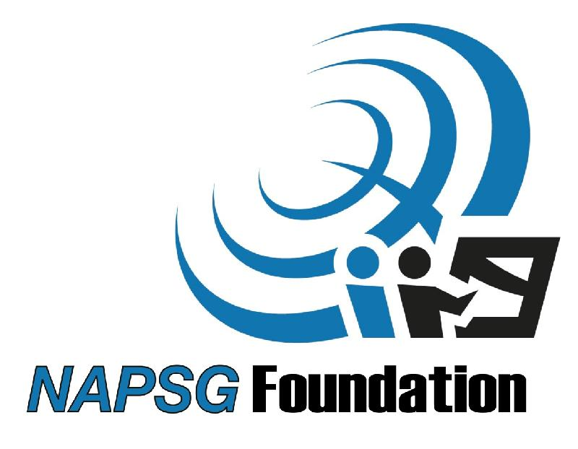

**Scholarship Program Intent:** NAPSG is pleased to be able to offer a limited number travel scholarship to support participation by local, state, and Tribal practitioners in the National Geospatial Preparedness Summit 2015, to be held on August 4 and 5 in Washington, DC. This NGPS scholarship program is intended to aid practitioners who would not otherwise be able to attend due to lack of travel funding. Scholarship applications will be reviewed on a bi-weekly basis and not all scholarship applicants will be selected. NAPSG reserves the right to accept or deny any scholarship application.

**Applicant Eligibility:** Scholarship applicants must be active-duty local, state, or Tribal public safety or GIS practitioners. They must officially represent a local or state government agency or Tribal organization. Public safety refers to, but is not limited to: fire service, emergency medical services, law enforcement, search and rescue, emergency management, 911 dispatch, public health, animal emergency response, mass care, and fusion centers. Eligible applicants must be more than 70 miles from Washington, DC.

**Eligible Expenses:** The NGPS Scholarship Program will provide financial support only for air transportation and hotel accommodations to aid participation in the NGPS 2015. NAPSG will work with selected scholarship recipients to make airline reservations and cost effective hotel accommodations. Meals, ground transportation and incidentals are not eligible expenses under the scholarship program.

**APPLICATION FORM**

**First Name:** **Last Name:**

**Job Title:**

**Agency: Address:**

**Email: Phone:**

**Request: ___ Air Transportation ___ Hotel Accommodations:** Indicate number of nights **___**

**Reason for Request: ___ Agency unable to provide travel funding ___ Other hardship**: Please provide short explanation

Send your completed scholarship application to [Summit@publicsafetygis.org](mailto:Summit@publicsafetygis.org) by the application deadline, June 5, 2015. All scholarship applicants will be notified as to whether or not their application has been accepted or denied.

*National Geospatial Preparedness Summit 2015  
Travel Scholarship Application*

www.napsgfoundation.org

National Alliance for Public Safety GIS Foundation